## VISVESVARAYA TECHNOLOGICAL UNIVERSITY

### BELGAUM-590 014



**2021-2022**

**A Project Report on**

**“HOBBS-A place for your Hobbies”**

Submitted in partial fulfillment for the award of degree of

##### Bachelor of Engineering in

**Computer Science & Engineering**

by

**PRAGNYA Y S 1AT16CS077**

Under the Guidance of

#### Prof. REKHA S

Assistant Professor, Dept. of CSE, AIT



DEPARTMENT OF COMPUTER SCIENCE AND ENGINEERING

#### ATRIA INSTITUTE OF TECHNOLOGY

BANGALORE- 560024

2019-20

#### ATRIA INSTITUTE OF TECHNOLOGY

**Department of Compute Science & Engineering BANGALORE-560024**



**CERTIFICATE**

Certified that the project work entitled **“HOBBS- A place for your Hobbies”**, carried out by **Pragnya Y S (1AT16CS077),** a bonafide student of **Atria Institute of Technology,** in partial fulfilment for the award of Bachelor of Engineering in **Computer Science & Engineering of Visvesvaraya Technological University, Belgaum** during the academic year 2021-2022. It is certified that all corrections/suggestions indicated for Internal Assessment have been incorporated in the Report deposited in the departmental library. The project report has been approved as it satisfies requirement in respect of project work prescribed for the said degree.

|  |  |  |
| --- | --- | --- |
| **Signature of Guide** | **Signature of HOD** | **Signature of Principal** |
| **Srinivasachar G** | **Dr. Aishwarya P** | **Dr. K V Narayana Swamy** |

##### External Viva

**Name of the Examiners Signature with date**

1.

2.

# DECLARATION

PRAGNYA Y S, student of VI semester B.E in Computer Science & Engineering at Atria Institute of Technology, hereby declare that the project work entitled “HOBBS-A place for your Hobbies” has been carried out under the supervision of Prof. Srinivasarchar G, Assistant Professor, Dept. of CS&E, Atria Institute of Technology and submitted in partial fulfilment of the course requirements for the award of degree in B.E in Computer Science & Engineering of Visvesvaraya Technological University, Belagavi during the year 2019-2020. We further declare that the report has not been submitted to any other University for the award of any other degree.

##### Place: Bangalore PRAGNYA Y S

**Date: 1AT16CS077**

# ABSTRACT

Nowadays we see a lot of attention is given towards safe guarding our country or in this matter any country at their respective borders. Many army men risk their precious life on the borders of the country to help people have a peaceful night’s sleep without any worry. Captain AMIGO, is an army robot whose main intention is to save the lives of all the army men on the borders. It plays the role of a CAPTAIN that is leads from front by itself going into the risk prone areas and detecting if there is any danger to the soldiers. Also acts like a detective by taking the live footage of the enemies at the other side of the border and delivers the same to official in charge so that they can see what is happening and have a clear idea about it. This robot camouflages itself according to the surrounding area so that it doesn’t become all the way more evident to the enemies about its existence. With these been its key features it also has many other components like PIR sensor, Gas sensor, Metal sensor to find out more about the enemies’ place and also checks if our country’s army men will remain safe if they walk-in by the same path.

# ACKNOWLEDGEMENT

We express gratitude to our institution and management for providing us with good infrastructure, laboratory, facilities and inspiring staff, and whose gratitude was of immense help in completion of this project successfully.

We express our sincere gratitude to **Dr. K.V. NARAYANA SWAMY,** Principal, Atria Institute of Technology, for providing us the required environment and for his valuable suggestion.

Our sincere thanks to **Dr. AISHWARYA P,** Head of the Dept. Computer Science and Engineering, Atria Institute of Technology, for her valuable support and for rendering us resources for this project work.

We express our gratitude to **Prof. SRINIVASACHAR G,** Assistant Professor, Dept. of Computer Science and Engineering, Atria Institute of Technology, who guided us with valuable suggestions in completing this project at every stage.

Last but not the least, the project would not have been a success without the support of our **parents** and **friends**. Our sincere thanks should be rendered to everyone who helped us in all possible ways.

# TABLE OF CONTENTS

DECLARATION i

ABSTRACT ii

ACKNOWLEGMENT iii

LIST OF FIGURES. iv-v

LIST OF TABLES. vi

CHAPTER I INTRODUCTION [1-5]

* 1. HTML… 2
  2. CSS [3]
  3. Javascript… 3
  4. Purpose 3
  5. Objectives [4-5]

CHAPTER II LITERATURE SURVEY [6-10]

CHAPTER III SYSTEM REQUIREMENTS SPECIFICATION 11

* 1. Hardware Requirements… 11
  2. Software Requirements… 11

CHAPTER IV SYSTEM DESIGN [12-17]

* 1. Architectural Design [12-13]
  2. Data Flow Diagram [13-14]
  3. Class Diagram 15
  4. Use Case Diagram 16
  5. Sequence Diagram 17

CHAPTER V IMPLEMENTATION [18-41]

* 1. Arduino Mega [18-21]
  2. PIR Sensor [22-24]
  3. IR Sensor [24-26]
  4. Gas Sensor [26-27]
  5. Metal Detector [28-31]
  6. Color Sensor [31-33]
  7. DC Motor Driver [33-37]
  8. Electromagnetic Relays [38-39]

5.9 Node MCU [39-40]

5.10 Wi-Fi Camera [40-41]

CHAPTER VI SOFTWARE DESCRIPTION [42-53]

* 1. Arduino IDE [42-44]
     1. Overview [42-43]

6.1.2 Sketch [43-44]

6.1.3 Getting started with Arduino 44

* 1. Blynk App [45-52]
  2. Live Video Streaming [52-53]

CHAPTER VII RESULTS [54-56]

CHAPTER VIII APPLICATIONS AND FUTURE WORKS 57

* 1. Applications 57
  2. Future scope 57

CHAPTER IX CONCLUSION [58-59]

CHAPTER X PAPER PUBLICATION DETAILS 60

REFERENCES [61-62]

# LIST OF FIGURES

|  |  |  |
| --- | --- | --- |
| **FIGURE NO.** | **DESCRIPTION** | **PAGE NO.** |
| 1.1 | Army men in action | 01 |
| 4.1 | Block Diagram for Captain AMIGO | 12 |
| 4.2 | Data flow Diagram | 14 |
| 4.3 | Class Diagram | 15 |
| 4.4 | Use Case Diagram | 16 |
| 4.5 | Sequence Diagram | 17 |
| 5.1 | Arduino Mega 2560 Board | 19 |
| 5.2 | Pin Details and Communication of  Arduino Mega 2560 | 21 |
| 5.3 | PIR Sensor | 22 |
| 5.4 | Block Diagram of PIR Sensor | 23 |
| 5.5 | PIR Sensor Pin Configuration | 24 |
| 5.6 | IR Sensor | 24 |
| 5.7 | Working principle of IR Sensor | 25 |
| 5.8 | Gas Sensor | 26 |
| 5.9 | Metal Detector | 28 |
| 5.10 | Working of Metal Detector | 29 |
| 5.11 | Circuit Diagram of Metal Detector | 30 |
| 5.12 | Color Sensor | 31 |
| 5.13 | Working of Color Sensor | 32 |
| 5.14 | Interfacing of Color Sensor to Arduino | 33 |
| 5.15 | DC Motor Driver | 34 |
| 5.16 | Pin Details of L293D IC | 35 |
| 5.17 | H-Bridge Connection | 35 |
| 5.18 | Driver Circuit [L293D] Connection with Arduino | 37 |

|  |  |  |
| --- | --- | --- |
| 5.19 | Electromagnetic Relay | 38 |
| 5.20 | Pin Description of Electromagnetic  Relays | 39 |
| 5.21 | Node MCU | 39 |
| 5.22 | Wi-Fi Camera | 40 |
| 6.1 | Logo of Arduino | 42 |
| 6.2 | Pairing up of Blynk Server with Smart  phone | 46 |
| 6.3 | Creating a new project in Blynk App | 47 |
| 6.4 | Selecting ESP8266 Hardware Model  after creating Amigo | 48 |
| 6.5 | Few Functional widgets available | 49 |
| 6.6 | Snapshots of button and value display  settings | 50 |
| 6.7 | Snapshots of Gas and Metal sensors | 51 |
| 6.8 | Controlling the motion of robot  through mobile hotspot | 52 |
| 6.9 | Creating an account in V380 App | 53 |
| 6.10 | Snapshot of Video streaming Display  settings | 53 |
| 7.1 | Captain Amigo | 54 |
| 7.2 | Red color Detection | 54 |
| 7.3 | Green color Detection | 55 |
| 7.4 | Blue color Detection | 55 |
| 7.5 | Blynk app And V380 app snapshots | 56 |

# LIST OF TABLES

|  |  |  |
| --- | --- | --- |
| **TABLE NO.** | **PARTICULARS** | **PAGE NO.** |
| 4.1 | Block Diagram Functionalities | 13 |
| 5.1 | Output frequency scaling and Color  Display Representation | 32 |
| 5.2 | Motor control Operation | 36 |

**INTRODUCTION**

## CHAPTER I

A robot is an automatic mechanical device often resembling a human or an animal. Modern robots are usually guided by a computer program or electronic circuitry. Robots have replaced humans in performing repetitive and dangerous tasks. It majorly does work similar to human with less risks and efforts. When it comes to utilising a robot instead of an army man, everyone will find making a robot work a more feasible option as there is a high risk of losing a person’s life on the borders. Army robots are hence in more demand nowadays so that the safety of the army men is achieved to the maximum. In recent times we can see that countries all over the world are ready to spend and invest on any new technologies that safeguards the nation and their people. Captain AMIGO is a specialised army robot using IoT technologies. The word AMIGO is taken from the language Spanish which means “Friend”. The same is used as the robot’s name to bring out the message that Captain AMIGO is a friend to the entire nation as it puts itself in danger to save the army men from losing their precious life. Also, the captain in the name suggests that the robot leads from the front.



Fig 1.1: Army men in action

Basically, Army Robot is capable of performing tasks such as locomotion, metal detection, sensing the harmful gas and humans beneath the surface. Army Robot is an autonomous robot comprising of Wi-Fi camera which can be used as a spy. The main aim is to implement a Camouflaged technology based Wireless multifunctional Army Robot which can be controlled via mobile.

## IoT

IoT stands for “Internet of Things”. In 2013 the Global Standards Initiative on Internet of Things (IoT-GSI) defined the IoT as “the infrastructure of the information society”. IoT allows objects to be sensed or controlled remotely across existing network infrastructure, creating opportunities for more direct integration of the physical world into computer-based systems, and resulting in improved efficiency, accuracy and economic benefit in addition to reduced human intervention.

## Camouflage Technology

Active camouflage or adaptive camouflage is camouflage that adapts, often rapidly, to the surroundings of an object such as an animal or a military vehicle. In theory, active camouflage could provide perfect concealment from visual detection. Active camouflage is used in several groups of animals, including reptiles on land, and flatfish in the sea. Animals achieve active camouflage both by color change and by counter illumination (among marine animals).

This camouflage technology had begun with United States Air Force program which placed low-intensity blue lights on aircraft as counter illumination camouflage. As night skies are not pitch black, a 100 percent black-colored aircraft might be rendered visible. By emitting a small amount of blue light, the aircraft blends more effectively into the night sky.

Active camouflage may now be developed using organic light-emitting diodes (OLEDs) and other technologies which allow images to be projected onto irregularly shaped surfaces. Using visual data from a camera, an object could perhaps be camouflaged well enough to avoid detection by the human eye and optical sensors when stationary. Active camouflage could make moving targets more difficult to see. However, active camouflage

works best in one direction at a time, requiring knowledge of the relative positions of the observer and the concealed object.

## Wi-Fi Technology

The IEEE 802.11 (ISO/CEI 8802-11) is an international standard describing the characteristics of a wireless local network (WLAN). The name Wi-Fi (short for Wireless Fidelity) is originally the name given to the certification granted by the WECA (Wireless Ethernet Compatibility Alliance), the institution responsible for maintaining interoperability between devices under the 802.11 standard.

Wi-Fi allows us to create wireless local area networks at high speed. In practice, the Wi-Fi can connect laptops, desktops, other devices like printers, game consoles to a broadband connection (300 Mbps) over a radius of several meters indoors (usually between 20 and 50 meters). In an open environment, the range can reach over several hundred of meters in optimal conditions. The Internet service providers are starting to equip areas with high concentrations of internet users (stations, airports, hotels, trains, etc.) with wireless internet access. These access areas are called "hotspots".

## Purpose

The main motive behind Camouflage Robot is to reduce human losses in military operations or terrorist attacks. Camouflage Robot acts as a virtual spy and can be sent into the strategic locations of military importance for observation and warfare purpose. Since it's very hard to detect it by a naked human eye, the Camouflage robot can be also used to test the various security systems developed in the market and act as a measure to evaluate its efficiency. The idea of the Camouflage Robot is based on the chameleon’s camouflage techniques. The aim of the project is to design, manufacture and operate a robot via a smartphone, used as remote-control device, a small mobile robot which can duplicate the colors where it moves on, hence being camouflaged to the outside world. To achieve these goals, we used a LED matrix (RGB) which can diffuse uniform colors. Initially, the robot can camouflage itself in red, green and blue color. It can also receive and send information from Smartphone using IoT to further pilot motors which in turn drive the robot in any required direction. This army robot is confining with the camera, sensors, metal detector and PIR sensor to trace the intruders.

## Objectives

Human lives being invaluable need to be protected from risky tasks or operations that are usually carried out in military domains of any country. The main motive of this robot is to avert the danger the soldiers and military personnel has to go through in unfavourable conditions. One of the major operations in the army is to infiltrate the enemy campsite and gather vital information such as enemy camp layout or any other strategies, without being detected by the opposition. Hence this robot acts as a virtual spy by utilizing color sensor and RGB LEDs to camouflage itself and retrieve information.

The objective of using a color sensor is highlighted in this project which can virtually differentiate between the 3 primary colors red, blue and green and glow the respective LEDs. The LED strips that are fixed around the robot take the color of the shade sensed by the color sensor and work as a cloaking device.

Retrieving information needs to be uninterrupted and clear and hence the robot uses a wireless camera with live steaming and night vision. The camera’s ability to rotate 360 degrees and transfer message through audio increases its efficiency. The use of IOT platform to store the retrieved information is also justified by the robot.

Using Arduino Mega as the core processor meets the objectives and advantages that any other version of microcontrollers lacks. Node MCU is used in order to meet both the controller and 2-way communication link purposes. The existing system uses various complex components that not only increase the price but the durability of the robot. Hence using economically suitable components meets the objectives of an inexpensive virtual spy robot.

The robot tackles various other requirements that play a key role in avoiding human participation and reduces human loss. Detection of any enemy vehicle or personnel at a distance alerts the operator of the danger that may lie ahead. Also, the detection of any soldier or victim under the debris of an explosion or accident is vital for the rescue team. This robot fulfils both these requirements by using ultrasonic sensors and PIR sensors respectively. The main aim is to use Wi-Fi communication to relay the information from these sensors to the operators rather than using Zigbee or Bluetooth as used in the existing systems. Harmful gases is a common entity in the war field as a by-product of explosives and its property to be invisible to naked

eyes makes it highly harmful. Hence the robot uses a gas sensor installed to detect the harmful gases and its contents to alert the rescue operators.

Most of the bombs and detonators used in the present world are usually made up of some sort of metal or alloys. To use a metal detector to detect these explosives based on their metal content is one of the objectives of the robot.

Locomotion of the army robot in various terrains is essential for flawless working. Hence the robot incorporates DC motors for their motion to cancel out any disadvantages in stepper motors used in the existing systems. A system which can receive and decipher information received from the Smart phone using IOT to further pilot motors which in turn drive the robot in any required direction is established. The objectives of reduced cost and creating a multifunctional camouflaging army robot named Captain Amigo are met by this proposed system.

# LITERATURE SURVEY

**CHAPTER II**

The paper [1] deals with the design of Remote controllers to direct the orientation of robot and to operate the laser gun. Robot keeps on moving in two modes i.e., Manual mode and self-mode. It’s brought under user’s control in the case of manual mode. In self-mode, robot starts moving over surface and takes action according to the scenario. To detect the obstacles, Infrared sensors (left sensor and right sensor) are deployed in the front portion of the module. While moving on the surface, if the left sensor is detected, robot takes back the position for a moment and moves right. If the right sensor is detected, robot gets back and moves left. The main objective of this paper is to minimize human casualties in terrorist attack such as 26/11. The combat robot has been designed to tackle such a cruel terror attack. This robot is radio operated, self- powered, and has all the controls like a normal car. A wireless camera has been installed on it, so that it can monitor enemy remotely when required. It can silently enter into enemy area and send all the information through its’ tiny Camera eyes. This spy robot can be used in star hotels, shopping malls, jewellery show rooms, etc where there can be threat from intruders or terrorists. Since human life is always precious, these robots are the replacement of fighters against terrorist in war areas.

The paper [2] proposes a design of robot which will change its colour according to surrounding surfaces and can easily be hidden from enemies to keep the information confidential using chameleon’s camouflage technique. The constructed robot is also equipped with wireless camera that will help to keep eye on enemy territory and also various other sensors to increase its capabilities and output parameters obtained by sensor is monitored. The main intention behind the Camouflage Robot is to minimize the number of human losses in military operations, sting operations, terrorist attacks and many such operations which results in human death. Camouflage Robot can act as a personified spy and can be sent into the dangerous locations and those locations which are out of reach of humans for observations and evidences because a naked human eye can’t detect minute evidences very easily. This robot is also used in testing the various security systems developed in the market to measure the amount of efficiency it offers.

The wireless communication technologies are rapidly spreading to new areas, including automation, data acquisition, building control, monitoring systems and many more. Autonomous robotic system is an outstanding innovation of a modern technology. It has been able to provide significant support to mankind by accomplishing arduous tasks that are apparently infeasible for human beings to perform. The paper [3] proposes embedded robotic system detects alive human body in the catastrophic environments which is very helpful for rescue operations. Disasters can be of two kinds- natural and human-induced. Natural disasters are not under the control of human beings. The main aim of the paper is to implement a Wireless multipurpose Robot which can be controlled through PC using Zigbee interface and navigates around the disaster areas and tries to find the humans who need help and tries to identify the forest fire.

Most of the military organization now takes the help of robots to carry out many risky jobs that cannot be done by the soldier. These robots used in military are usually employed with the integrated system, including video screens, sensors, gripper and cameras. The military robots also have different shapes according to the purposes of each robot. Here the new system proposed in paper [4] with the help of low power Zigbee wireless sensor network to trace out the intruders (unknown persons) and the robot will take the necessary action automatically. Thus, the proposed system, an Intelligent Unmanned Robot (IUR) using Zigbee saves human live and reduces manual error in defence side. This is specially designed robotic system to save human life and protect the country from enemies.

The paper [5] describes about BAE (British Aerospace Engineering) Systems announcing Adaptive infrared camouflage technology. It uses about 1000 hexagonal panels to cover the sides of a tank. The panels are rapidly heated and cooled to match either the temperature of the vehicle's surroundings, or one of the objects in the thermal cloaking system's "library" such as a truck, car or large rock. Stealth technology also termed LO technology (low observable technology) is a sub-discipline of military tactics and passive electronic countermeasures, which cover a range of techniques used with personnel, aircraft, ships, submarines, missiles and satellites to make them less visible (ideally invisible) to radar, infrared, sonar and other detection methods. To achieve the feat of 'cloaking' an object, they have developed what are known as meta materials, some of which can bend electromagnetic radiation, such as light, around an object, giving the appearance that is not there.

The paper [6] proposes bio-inspiration work based on chromatic behaviour change with respect to multiple predators. Here the robot exhibits similar concept showcasing difference in colour response on detecting multiple predators. Dwarf chameleons alter their detection ability by encompassing difference in its exposure values with that of the surroundings. The exposure values are said to be maximum detectable on encountering species of their own kind and minimum detectable on encountering its predators. A simple example to this can be noticed by the camouflage feature of a chameleon exhibiting a brighter exposure contrast as stealth in presence of a snake and a lower exposure in presence of a bird respectively. These chromatic behavioural changes are incorporated to our cylindrical based prototype which basically involves many stages as described further. The robot can be controlled automatically or by tele- operation. In the tele-operation the controlling is by mobile device noticing the changes through a visual streaming camera onboard. The robot is initially free to roam, if and only if it encounters a hostile or friendly agent the next phase starts. Here in the next phase on detecting its predators it changes itself to a significant colour and also is programmed to remain still in stealth for exhibiting effective camouflaging. If the robot encounters species of its own then it changes to a detectable colour. Here the colour changing is exhibited based on the visual characteristics of the surrounding terrain.

The paper [7] describes about the basic functionalities that takes place in the following

phases:

* + 1. Kinect camera at the back of LCD, captures the BG scene of the camouflage object and then sends the captured images to the computer for real time processing.
    2. Kinect camera mounted on the display, tracks the observer’s eyes and his skeleton, and then sends the 3D location of his eyes in real time.
    3. The occluded region behind the object depends on its size and its location with respect to the location of the observer’s eyes, i.e. LCD that covers the camouflaged object.
    4. The computer processes the RGB and depth images received from back camera and the tracking information from front camera, which are the tracking status, face features, 2D tracked points, 3D tracked head joint point, and head pose (pitch, roll, and yaw, with working range of 20° ,90°, 45° respectively).
    5. The camouflaged image with appropriate scale and location sends to the LCD display.

The paper [8] is concerned with the development of a cognitive robot-ant for inspection of real environments such as riverside, seaside, river/channel orifices, canalization vicinity, etc. The primary task of the robot is to acquire data on the condition of the ecology system and to do some simple cleaning tasks. The robot is provided with on board cameras and a wide array of different specialized sensors. The data and images are sent to the corresponding supervision centre. Here they are processed and connected to geographical information which is collected from a web of sources. Thus, providing the high-level commands for the robot operation. The robot navigates autonomously, following the high-level instructions obtained from the surveillance centre. It is off-the-shelf, robust wheel-based robot capable of operating on regular as well as irregular terrains. Heterogeneous system consists of sensors for detection (such as LIDAR, GPS), Visual sensors and non-visual perception sensors. TCP/IP communication with the remote surveillance centre enabled over GPRS/EDGE/3G services is used. The robot has following modules:

* + - 1. Versatile perception
      2. Artificial Intelligence
      3. Locomotion System
      4. Arm(s)

The paper [9] describes about an intelligent detection process which is divided into two phases: Learning phase including in the offline process and Test phase which is a part of the online process. The former includes the preparation of the database files. SIFT and HOG features are the inputs of the AdaBoost algorithm learning and the decision person or not is the output of the network. The second phase of our human detection algorithm identifies if humans exist in the extracted image and where they are in the video sequences. For that AdaBoost is trained to recognize the shape of a human. The trained AdaBoost is then used to identify which of the connected components are human or not. The main advantages of this method are its high speed and performance. It is based on the combination of several weak classifiers which, in average, have a moderate precision and create a strong classifier. The AdaBoost provides both learning and classification operators. In order to implement both algorithms, we have used GML AdaBoost Matlab Toolbox 1 with AdaBoost algorithm implementation. The detection of people is done by sliding a search window through the frame image and checking whether an

image region at a certain location is classified as human or non-human. The system can detect standing individuals at different positions, orientations, and with different backgrounds.

In paper [10], the segmentation technique used here is motivated by the observation that for most of the domains of interest here changes in illumination lead to small changes in colour value and that these changes are relatively uniform across all colours. So, with modern cameras with automatic shutters and gain control red pixels may vary in colour but will stay in the same region of colour space. The different methods used for colour recognition are:

1. Pixel Classification: To label pixels according to which symbolic class they belong to, we use a soft-labelling scheme followed by a hard decision based on adaptive thresholds. The pixel is assigned to the highest priority colour class for which its likelihood is above the threshold for that colour class.
2. Threshold Adaptation: A histogram-based approach is used to adapt the threshold from frame to frame. the key assumption here is that pixels in the image are drawn from two different underlying distributions: pixels that belong to the colour class of interest and pixels that do not. the key assumption translates to a histogram of likelihood values consisting of two, clearly distinguishable Gaussian peaks centered around likelihood values of 1, and 0, respectively. The peak with the highest likelihood value corresponds to the pixels of interest.
3. Region Extraction: Once the image has been segmented, regions of similarly labelled pixels are found using connected component analysis. CM Vision provides fast connected components using a combination of run length encoding and run conglomeration.
4. Object Recognition: Once an image has been segmented and coloured regions extracted, high-level vision must attempt to detect and recognize relevant objects in the image if any are present.

# SYSTEM REQUIREMENTS SPECIFICATION

## Hardware Requirements

*Device name: DESKTOP-TFTP419 * Processor: Intel® Core™ i5-7200U

*RAM: 8.00 GB

** System type: 64-bit operating system, x64-based processor Arduino UNO

** Colour sensor PIR sensor

** IR sensor Metal sensor

** GAS sensor Relay

** Wi-Fi Camera Wi-Fi module

* Power supply system

## Software Requirements

** Windows 10 Home Single Language Arduino IDE- version: 1.8.10

** Blynk App V380 Pro App

# SYSTEM DESIGN

System design is the process of defining the architecture, components, modules, interfaces, and data for a system to satisfy specified requirements. Systems design could be seen as the application of systems theory to product development.

## Architectural Design

System architecture is a conceptual model that defines the structure and behaviour of the system. It comprises of the system components and the relationships describing how they work together to implement the overall system. The Fig 4.1 below shows the system’s architecture and the various components added to them. Majorly Arduino is used to connect various sensors as shown below.

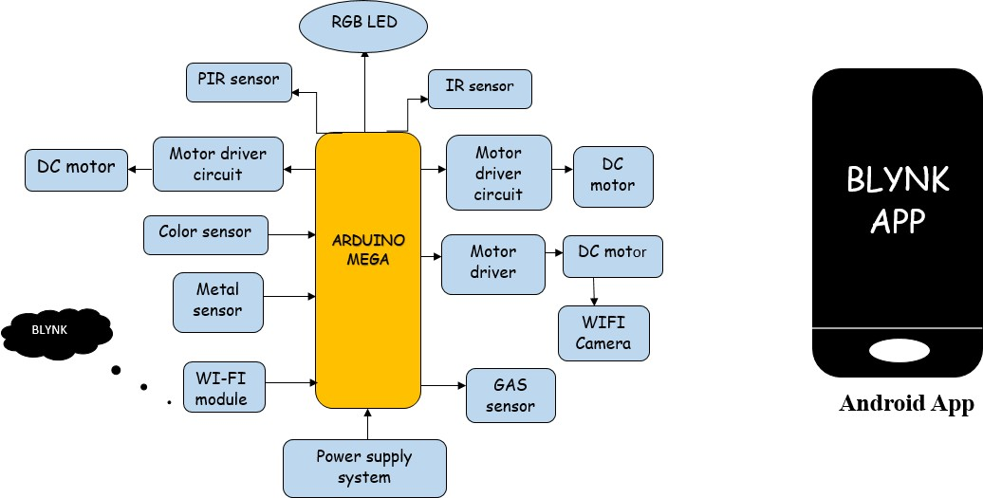

Fig 4.1: Block Diagram for Captain AMIGO

The description of each component from the block diagram above and their major functionalities with respect to the AMIGO robot as a complete unit is described in the table below.

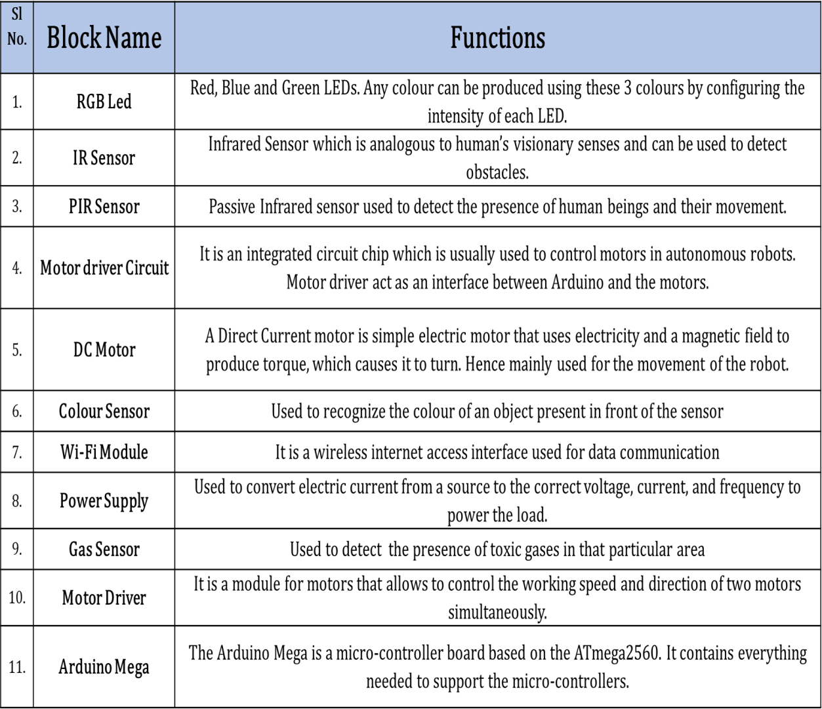

Table 4.1: Block Diagram functionalities

## Data Flow Diagram

A data flow diagram is a graphical representation of the "flow" of data through an information system, modelling its process aspects. It is often used as a preliminary step to create an overview of the system without going into great detail, which can later be elaborated. They can also be used for the visualization of data processing.

A Data Flow Diagram shows what kind of information will be input to and output from the system, how the data will advance through the system, and where the data will be stored. It does not show information about the timing of process or information about whether processes will operate in sequence or in parallel unlike a flowchart which also shows this information.

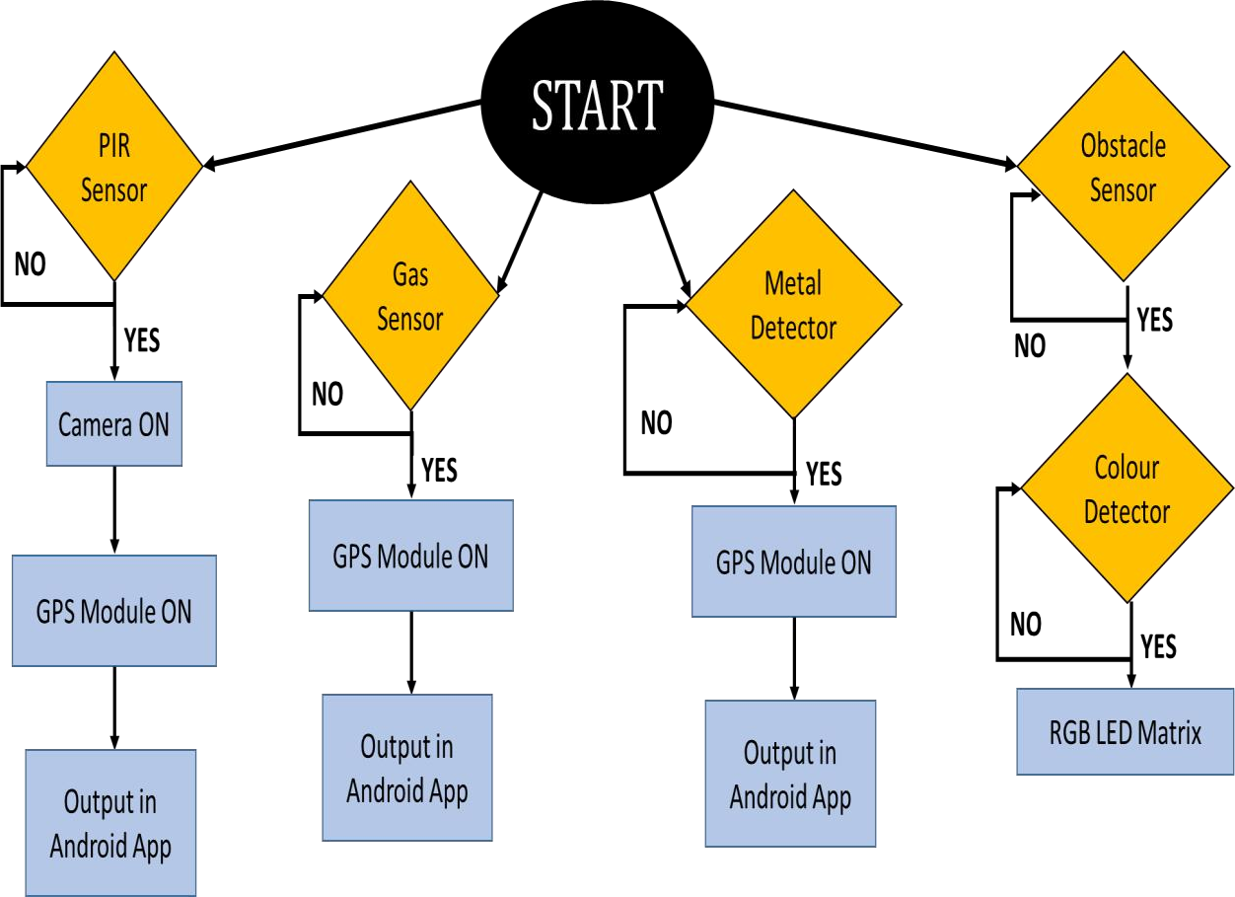

Fig 4.2: Data flow Diagram for Captain AMIGO

The above figure represents the data flow diagram of the camouflage army robot. It contains five sensors, namely:

* + 1. Obstacle Sensor
    2. PIR Sensor
    3. Colour Detector
    4. Metal Detector
    5. Gas Sensor

In the course of robot movement if any obstacle is sensed then, it is detected first. Later, the colour is detected by using colour sensor and that particular colour is displayed in the RGB colour matrix. If any human comes that is detected by PIR sensor and as soon as the human is detected, camera and GPS turns on and that particular live video is sent to the android app.

If any landmines are present then metal detector detects it and through GPS information will be sent to the android app. If any leakage of gases is present then those gases are detected by gas sensor and that particular information is sent to the android app.

## Class Diagram

Class diagram is a static diagram. It represents the static view of an application. Class diagram is not only used for visualizing, describing, and documenting different aspects of a system but also for constructing executable code of the software application.

Class diagram shows a collection of classes, interfaces, associations, collaborations, and constraints. It is also known as a structural diagram.

The different classes considered are sensors, motors, micro controller and android applications. The sensors used are IR, PIR, gas, metal and colour sensors having their own uses according to the requirements. The micro controller receives the data sent by the sensors and does the tasks like processing and controlling the received data. The motors get the information from the micro controller pertaining to the movement of the motor like forward, backward, left or right. With the help of Wi-Fi module, the android apps send and receive data from and to the micro controller and motor driver.

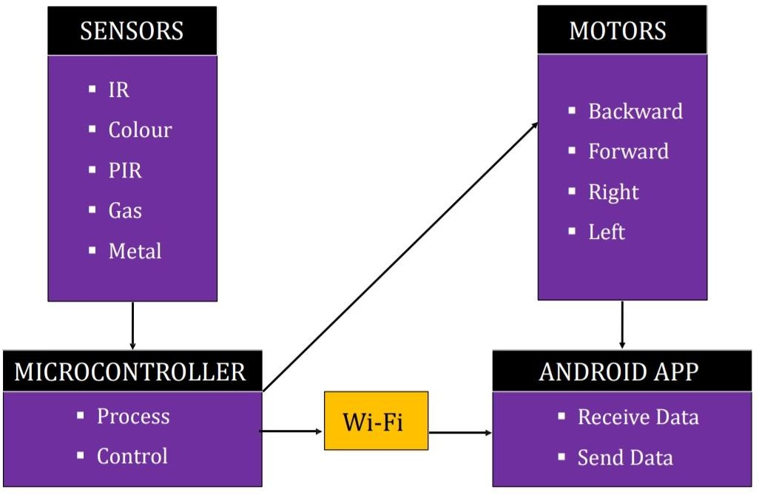

Fig 4.3: Class Diagram for Captain AMIGO

## Use Case Diagram

A use case diagram at its simplest is a representation of a user's interaction with the system that shows the relationship between the user and the different use cases in which the user is involved. A use case diagram can identify the different types of users of a system and the different use cases and will often be accompanied by other types of diagrams as well.

While a use case itself might drill into a lot of detail about every possibility, a use-case diagram can help provide a higher-level view of the system. It has been said before that "Use case diagrams are the blueprints for your system". They provide the simplified and graphical representation of what the system must actually do. The self-explanatory use case diagram is as shown in the following figure (Fig 4.4).

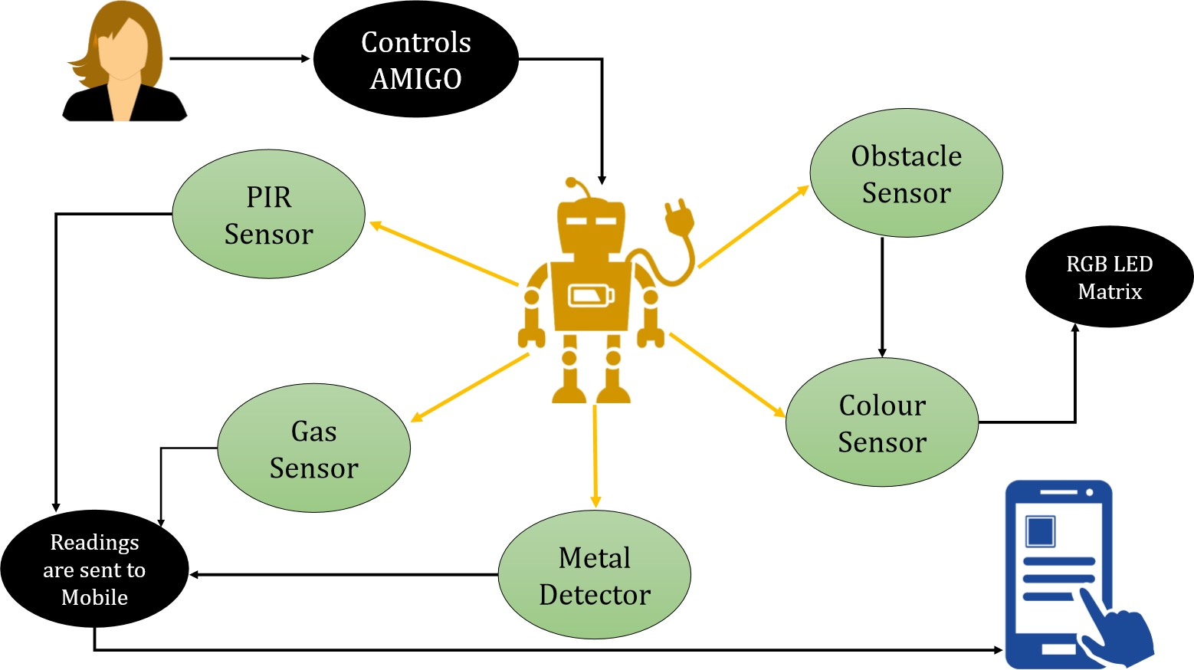

Fig 4.4: Use Case Diagram for Captain AMIGO

## Sequence Diagram

A sequence diagram shows object interactions arranged in time sequence. It depicts the objects and classes involved in the scenario and the sequence of messages exchanged between the objects needed to carry out the functionality of the scenario. Sequence diagrams are typically associated with use case realizations in the Logical View of the system under development. Sequence diagrams are sometimes called event diagrams or event scenarios.

A sequence diagram consists of parallel vertical lines (lifelines) which shows different processes or objects that live simultaneously, and horizontal arrows that depicts the messages exchanged between them, in the order in which they occur. This allows the specification of simple runtime scenarios in a graphical manner.

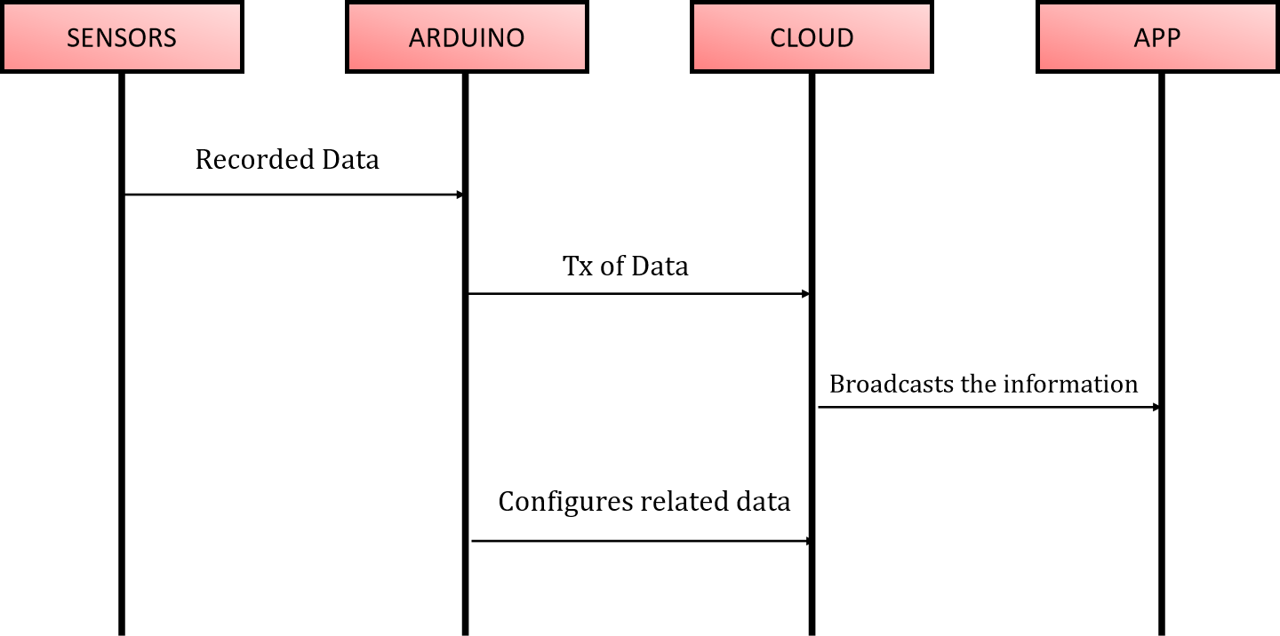

Fig 4.3: Sequence Diagram for Captain AMIGO

# IMPLEMENTATION

## CHAPTER V

System Implementation uses the structure created during architectural design and the results of system analysis to construct system elements that meet the stakeholder requirements and system requirements developed in the early life cycle phases. These system elements are then integrated to form intermediate aggregates and finally the complete system-of-interest (SoI). Implementation is the process that actually yields the lowest-level system elements in the system hierarchy (system breakdown structure). System elements are made, bought, or reused. Production involves the hardware fabrication processes of forming, removing, joining, and finishing, the software realization processes of coding and testing, or the operational procedures development processes for operators' roles.

Modular design, or "modularity in design", is a design approach that subdivides a system into smaller parts called modules or skids, that can be independently created and then used in different systems. A modular system can be characterized by functional partitioning into discrete scalable, reusable modules; rigorous use of well-defined modular interfaces; and making use of industry standards for interfaces.

## Arduino Mega

The Arduino Mega 2560 is a microcontroller board based on the ATmega2560 (datasheet). It has 54 digital input/output pins (of which 14 can be used as PWM outputs), 16 analog inputs, 4 UARTs (hardware serial ports), a 16 MHz crystal oscillator, a USB connection, a power jack, an ICSP header, and a reset button. It contains everything needed to support the microcontroller.

The Arduino Mega can be powered via the USB connection or with an external power supply. The power source is selected automatically. External (non-USB) power can come either from an AC-to-DC adapter or battery. The adapter can be connected by plugging a 2.1mm center-positive plug into the board's power jack. Leads from a battery can be inserted in the Gnd and Vcc/Vin pin headers of the POWER connector. The board can operate on an external supply of 6 to 20 volts. If supplied with less than 7V, however, the 5V pin may supply less than

five volts and the board may be unstable. If using more than 12V, the voltage regulator may overheat and damage the board. The recommended range is 7 to 12 volts. The Mega2560 differs from all preceding boards as it does not use the FTDI USB-to-serial driver chip. Instead, it features the Atmega8U2 programmed as a USB-to-serial converter.

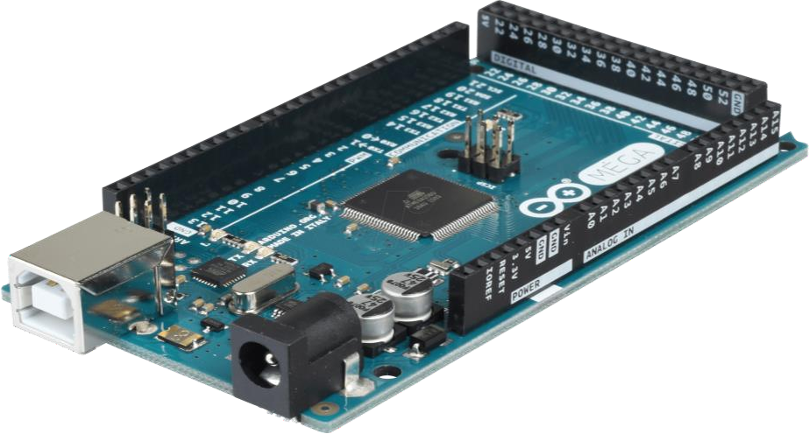

Fig 5.1: Arduino Mega 2560 Board The detailed specifications are as follows:

**VIN**: The input voltage to the Arduino board when it's using an external power source (as opposed to 5 volts from the USB connection or other regulated power source). You can supply voltage through this pin, or, if supplying voltage via the power jack, access it through this pin.

**5V**: The regulated power supply used to power the microcontroller and other components on the board. This can come either from VIN via an on-board regulator, or be supplied by USB or another regulated 5V supply.

**3V3**: A 3.3volt supply generated by the on-board regulator. Maximum current draw is 50 mA.

**GND**: Ground pins.

**Memory**: The ATmega2560 has 256 KB of flash memory for storing code (of which 8 KB is used for the bootloader), 8 KB of SRAM and 4 KB of EEPROM (which can be read and written with the EEPROM library).

**Input and Output**: Each of the 54 digital pins on the Mega can be used as an input or output, using pinMode(), digitalWrite(), and digitalRead() functions. They operate at 5 volts.

**External Interrupts**: 2 (interrupt 0), 3 (interrupt 1), 18 (interrupt 5), 19 (interrupt 4), 20 (interrupt 3), and 21 (interrupt 2). These pins can be configured to trigger an interrupt on a low value, a rising or falling edge, or a change in value.

**PWM**: 0 to 13. Provide 8-bit PWM output with the analogWrite() function.

**SPI**: 50 (MISO), 51 (MOSI), 52 (SCK), 53 (SS). These pins support SPI communication using the SPI library. The SPI pins are also broken out on the ICSP header, which is physically compatible with the Uno, Duemilanove and Diecimila.

**LED 13**: There is a built-in LED connected to digital pin 13. When the pin is HIGH value, the LED is on, when the pin is LOW, it is off.

**I2C**: 20 (SDA) and 21 (SCL). Support I2C (TWI) communication.

**AREF**: Reference voltage for the analog inputs. Used with analogReference().

**Reset**: Bring this line LOW to reset the microcontroller. Typically used to add a reset button to shields which block the one on the board.

**Communication**: The Arduino Mega2560 has a number of facilities for communicating with a computer, another Arduino, or other microcontrollers. The ATmega2560 provides four hardware UARTs for TTL (5V) serial communication. An ATmega8U2 on the board channels one of these over USB and provides a virtual com port to software on the computer. The Arduino software includes a serial monitor which allows simple textual data to be sent to and from the board. The RX and TX LEDs on the board will flash when data is being transmitted via the ATmega8U2 chip and USB connection to the computer (but not for serial communication on pins 0 and 1). A SoftwareSerial library allows for serial communication on any of the Mega2560's digital pins. The ATmega2560 also supports I2C (TWI) and SPI communication. The Arduino software includes a Wire library to simplify use of the I2C bus and SPI library for SPI communication.

**Programming**: The Arduino Mega can be programmed with the Arduino software. The ATmega2560 on the Arduino Mega comes preburned with a bootloader that allows you to upload new code to it without the use of an external hardware programmer. It communicates using the original STK500 protocol (reference, C header files). We can also bypass the

bootloader and program the microcontroller through the ICSP (In-Circuit Serial Programming) header.

**Automatic (Software) Reset**: Rather than requiring a physical press of the reset button before an upload, the Arduino Mega2560 is designed in a way that allows it to be reset by software running on a connected computer. One of the hardware flow control lines (DTR) of the ATmega8U2 is connected to the reset line of the ATmega2560 via a 100 nanofarad capacitor. When this line is asserted (taken low), the reset line drops long enough to reset the chip. The Arduino software uses this capability to allow you to upload code by simply pressing the upload button in the Arduino environment. This means that the bootloader can have a shorter timeout, as the lowering of DTR can be well-coordinated with the start of the upload. This setup has other implications. When the Mega2560 is connected to either a computer running Mac OS X or Linux, it resets each time a connection is made to it from software (via USB).

**USB Overcurrent Protection**: The Arduino Mega2560 has a resettable polyfuse that protects your computer's USB ports from shorts and over current. Although most computers provide their own internal protection, the fuse provides an extra layer of protection. If more than 500 mA is applied to the USB port, the fuse will automatically break the connection until the short or overload is removed.

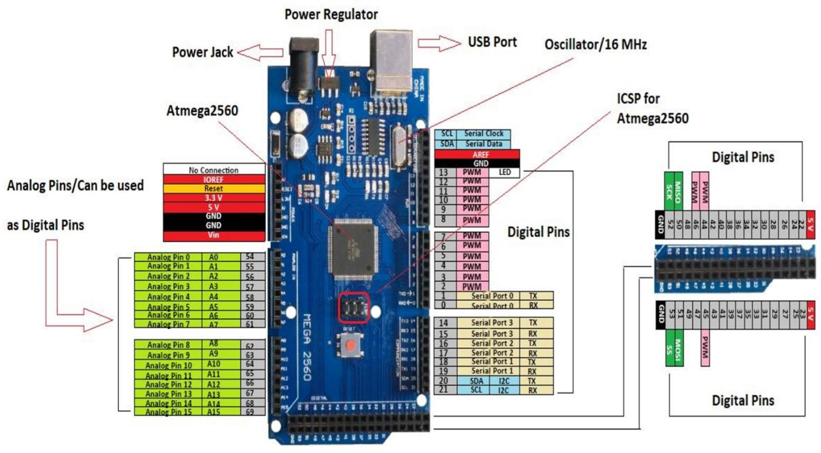

Fig 5.2: Pin Details and Communication of Arduino Mega 2560

## PIR Sensor

The passive infrared or electrolytic or IP motion sensor (PIR) are basically made of a electrolytic sensor that can detects the level of infrared radiation. It detects (infrared energy) heat energy radiated or emitted by an object like a body of a person moving across a field of view of a heat sensor of the motion detection system.

Fundamentally, pyroelectric sensors that detect the levels of infrared radiation are used to make PIR sensors. There are different types of PIR sensor circuits used in numerous electronics applications which are used to discover a human being entering or leaving the particular area or room. These passive infrared sensors are flat control, consists of a wide range of lens, and PIR sensors can be easily interfaced with electronic circuits. The PIR sensor circuit consists of three pins, power supply pin, output signal pin, and ground pin. The PIR sensor circuit is having ceramic substrate and filter window as shown in the figure and also having dome like structure called as Fresnel lens.

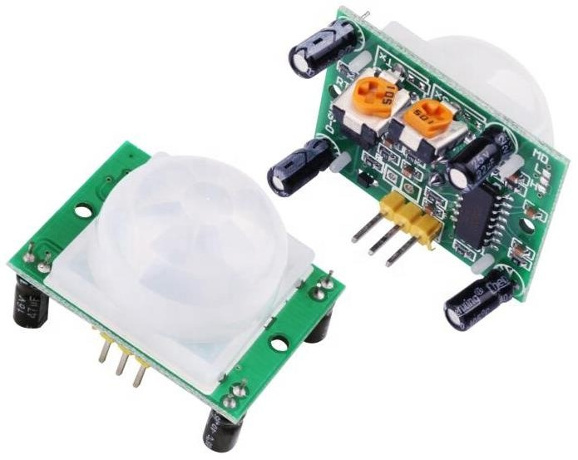

Fig 5.3: PIR Sensor

Generally, the PIR sensor power is up to 5V, but, the large size PIR modules operate a relay instead of direct output. It is very simple and easy to interface the sensor with a microcontroller. The output of the PIR is (usually digital output) either low or high. Whenever, human being (even a warm body or object with some temperature) passes through the field of view of PIR sensor, it detects the infrared radiation emitted by a hot body motion. Thus, the

infrared radiation detected by the sensor generates an electrical signal that can be used to activate an alert system or buzzer or alarm sound.

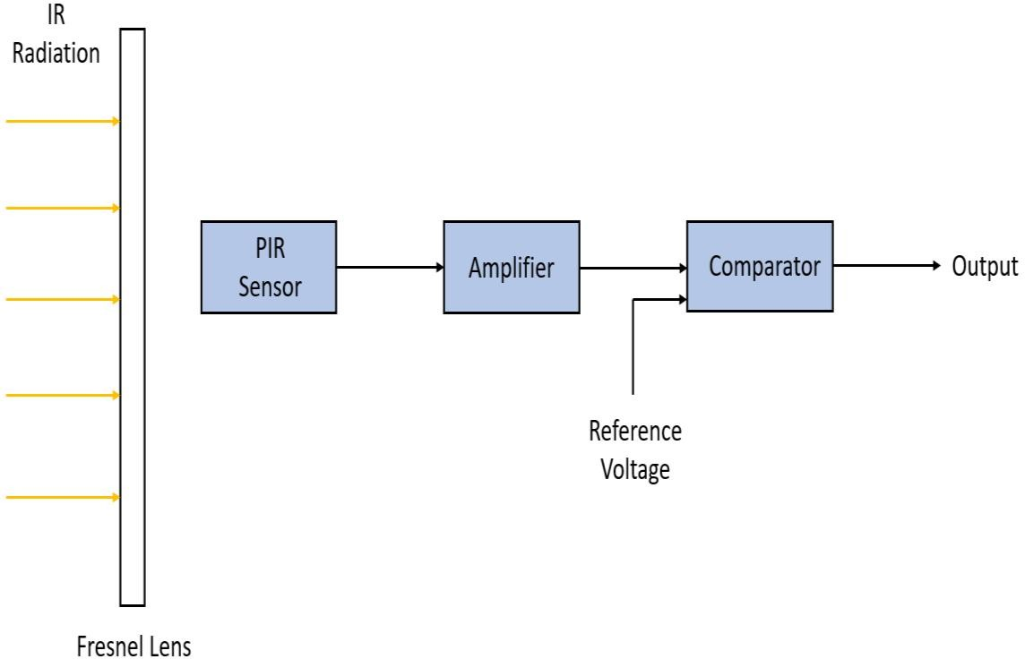

Fig 5.4: Block Diagram of PIR Sensor

The pin configuration of the PIR sensor is shown in the figure (Fig 5.5). PIR sensor consists of three pins, ground, signal, and power at the side or bottom. Generally, the PIR sensor power is upto 5V but, the large size PIR modules operate a relay instead of direct output. It is very simple and easy to interface the sensor with a microcontroller. The output of the PIR is (usually digital output) either low or high. The PIR sensor internally is split into two halves, one half is positive and the other is considered as negative. Thus, one half generates one signal by detecting the motion of a hot body and other half generates another signal. The difference between these two signals is generated as output signal. Primarily, this sensor consists of Fresnel lens which are bifurcated to detect the infrared radiation produced by the motion of hot body over a wide range or specific area. This sensor requires settling time, which is characteristically in the range of 10 to 60 seconds.

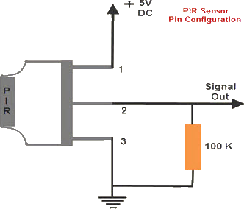

Fig 5.5: PIR Sensor Pin Configuration Some of the applications of these PIR sensors are as follows:

** PIR Sensor based Automatic Door Opening System PIR Sensor based Security Alarm System

* They are able to sense the detection of people and other objects

*PIR sensors are also used in automatic lightening systems. In these types of systems, when a person comes in the vicinity of the sensor then, the lights are automatically turned ON.

* They are used in outdoor lightening systems and also in some lift lobbies.

## IR Sensor

Infrared Sensor which is analogous to human’s visionary senses and can be used to detect obstacles. An infrared sensor is an electronic device, that emits in order to sense some aspects of the surroundings. It can measure the heat of an object as well as detects the motion.

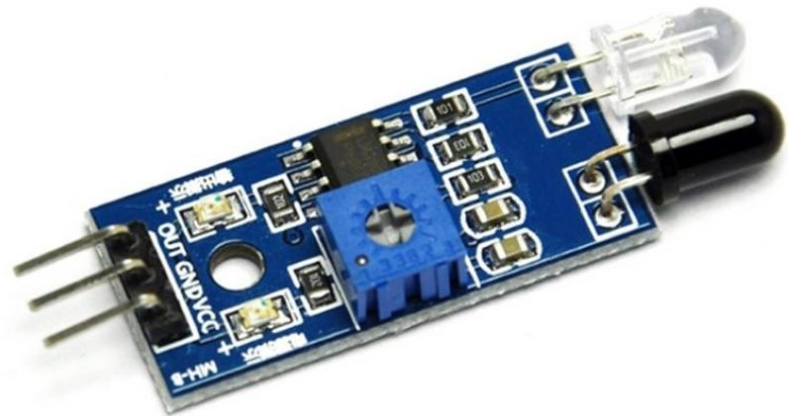

Fig 5.6: IR Sensor

An IR Sensor consists of two parts, the emitter circuit and the receiver circuit. This is collectively known as a photo-coupler or an optocoupler. The emitter is an IR LED and detectors are IR Photodiode. The IR photodiode is sensitive to the IR light emitted by an IR LED. The photo-diode’s resistance and output voltage change in proportion to the IR light received. The type of incidence can be direct incidence or indirect incidence. In direct incidence, the IR LED is placed in front of a photodiode with no obstacle in between. In indirect incidence, both the diodes are placed side by side with an opaque object in front of the sensor. The light from the IR LED hits the opaque surface and reflects back to the photodiode. The principle of working of an IR sensor is as shown in the following figure.

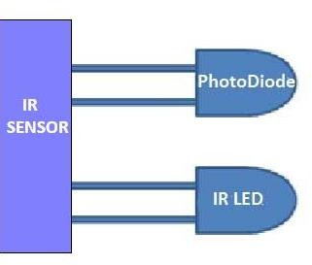

*Reflected IR Light*

*IR Light*

Fig 5.7: Working principle of IR Sensor The advantages of IR Sensors are as follows:

*Speed

*Lack of Interference

***Ability to measure in high temperature upto 3000 ° C Long lasting measurement, no mechanical wear Optimization of manufacturing processes

**Fever inspection of patients or travellers. Line scanning in glass toughening lines

**Checking mechanical or electrical equipment for temperature and hot spots. Checking heater or oven temperature, for calibration and control.

*Checking for hot spots in fire-fighting.

* Their low power requirements make them suitable for most electronic devices such as laptops, telephones etc.,

* They are capable of detecting motion in presence/ absence of light almost with same reliability.

* They do not require contact with object to for detection.

*There is no leakage of data due to beam directionality IR radiation.

* They are not affected by corrosion or oxidation.

*They have very strong noise immunity.

## Gas Sensor

This gas sensor is suitable for detecting different types of gases. It is suitable for detecting Alcohol, Benzine, CH4, Hexane, LPG, CO (carbon monoxide) gases. It has a high sensitivity and fast response time. This module is made using Alcohol Gas Sensor MQ3. It is a low-cost semiconductor sensor which can detect the presence of alcohol gases at concentrations from 0.05 mg/L to 10 mg/L.

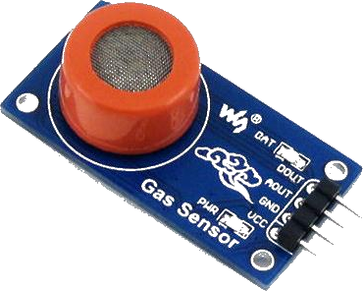

Fig 5.8: Gas Sensor

The sensitive material used for this sensor is SnO2, whose conductivity is lower in clean air. Its conductivity increases as the concentration of alcohol gases increases. It has high sensitivity to alcohol and has a good resistance to disturbances due to smoke, vapor and

gasoline. This module provides both digital and analog outputs. MQ3 alcohol sensor module can be easily interfaced with Microcontrollers, Arduino Boards, Raspberry Pi etc. This alcohol sensor is suitable for detecting alcohol concentration on your breath, just like your common Breathalyzer.

It has a high sensitivity and fast response time. Sensor provides an analog resistive output based on alcohol concentration. The drive circuit is very simple, all it needs is one resistor. A simple interface could be a 0-3.3V ADC.

##### Features

* 5V operation, Simple to use
* LEDs for output and power, Output sensitivity adjustable
* Analog output 0V to 5V & Digital output 0V or 5V Low Cost
* Fast Response
* Both Digital and Analog Outputs
* On-board LED Indicator

##### Technical Data

* Concentration: 0.05 mg/L ~ 10 mg/L Alcohol
* Operating Voltage: 5V ±0.1
* Current Consumption: 150mA
* Operation Temperature: -10°C ~ 70°C

##### Pin Out

* VCC – Input Power Supply
* GND – Supply Ground
* DO – Digital Output
* AO – Analog Output

##### Applications

* Vehicle Alcohol Detector
* Portable Alcohol Detector

## Metal Detector

Nowadays, the metal detector is used to identify metallic devices such as bombs, guns for security purpose. To avoid any illegal or unauthorized entry of metallic objects, bombs, knives, guns within the luggage bags of the person carrying them in public places like theatres, shopping malls, parks, airports, hotels, railway stations. A security system is developed by using proximity sensor which is named as a metal detector. So, a metal detector is used in many robotic or electronics projects to detect any present metals which are nearby or the existence of hidden items within objects.

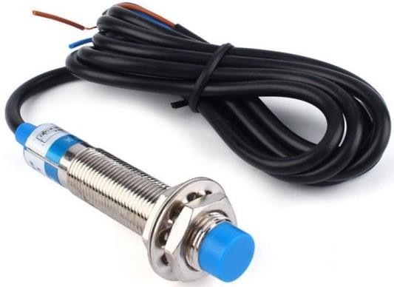

Fig 5.9: Metal Detector

In the year 1960, the first metal detector was established and was used in industrial applications and mineral prospecting. A metal detector is an electronic device that comprises of an oscillator which generates an AC current that passes via a coil generating an alternating magnetic field. When a part of the metal is nearby to the coil, eddy current will be induced in the metal object & this generates a magnetic field of its own. If an extra coil is used to measure the magnetic field, the magnetic field can be changed and sensed due to the metal object. The metal detectors are used to sense the weapons and also used in the construction industry to identify the steel reinforcing bars in pipes, concrete, wires, pipes buried in walls & floors.

Metal detector types are classified into three types such as BFO (Beat Frequency Oscillation), TR (Transmitter or Receiver) and VLF (Very Low frequency). The metal detector working is, when the electromagnetic field is transmitted from the search coil into the earth. Metals in the electromagnetic field will become strengthened & resend an electromagnetic of

their own. The metal detector comprises of a search coil which receives the retransmitted field & alarms the user by generating a response of the metal. Minelab metal detectors are accomplished by discriminating between dissimilar types of targets and can be fixed to ignore unwanted metal objects.

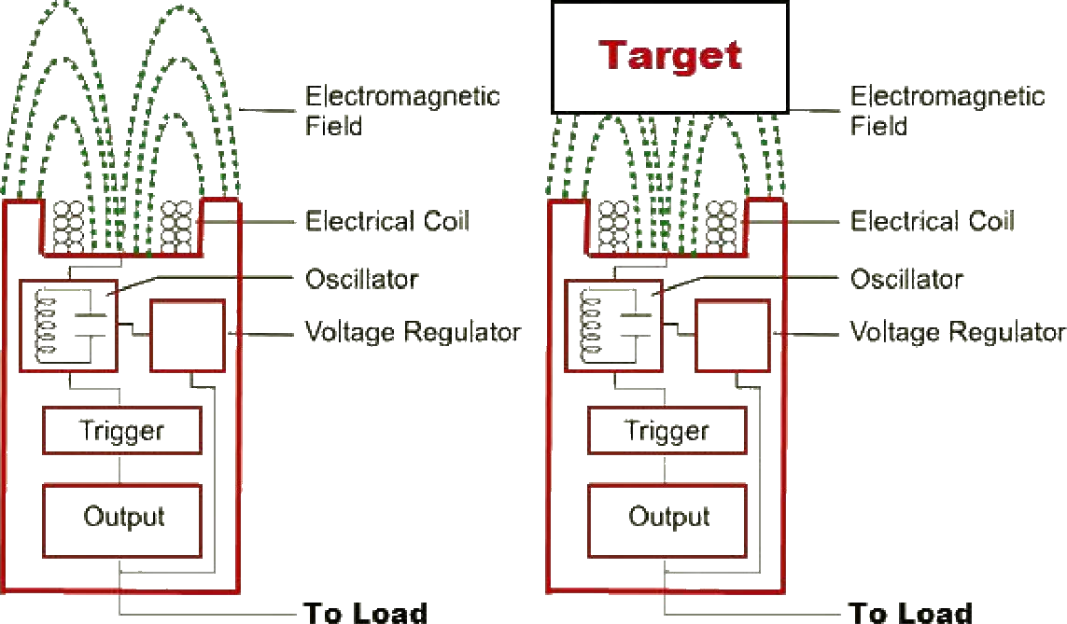

Fig 5.10: Working of Metal Detector

The main purpose of the battery is to provide the power to the detector. The control box comprises of the electronics of the detector. When the transmit signal is generated, the receive signal is processed and transformed into a target response. The electromagnetic field can be transferred by the search coil of the detector into the ground & receives the electromagnetic field return from a metal object. The transmitted electromagnetic field energizes metal objects to allow them to be sensed. Here, a target is a metal object that can be sensed by a metal detector. In this, the target is treasure which is sensed and that is a good target. These metal objects are generally attracted to a magnet like nails and also non-ferrous like bottle tops. If the metal detector is fixed to discard unwanted targets, then the response of the target will not be generated for those targets. The receive electromagnetic field is produced from energized targets & it is received by the search coil.

The metal detector circuit built with an LC circuit, buzzer and simple proximity sensor. In LC circuit, capacitor and inductor are connected in parallel. When the circuit detects any

metal near to it, then the circuit activates the proximity sensor and its glow the LED and makes a buzzer.

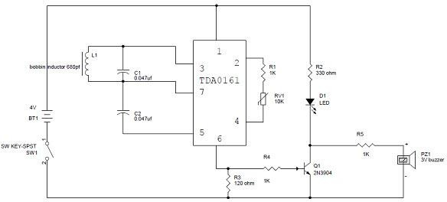

Fig 5.11: Circuit Diagram of Metal Detector

When this circuit has any resonating frequency from any target which is near to it, then the electric field will be created, which will lead to induce current in the coil and change the S/L in the flow of the S/L through the coil. The value of the sensor can be changed by using a variable resistor, that is equal to the LC circuit. When the metal is detected, the circuit will have new signal and respond accordingly. When the metal object is sensed by the coil, the sensor’s output will be of 1mA. When the coil is close to the target, then the output of the sensor will be around 10mA. When the output pin is high, the resistor R3 will offer a positive voltage to the Q1 transistor to turn ON the LED, which will glow and generate a buzzer sound. Here, resistor R2 is mainly used to restrict the current flow.

Few applications of Metal detectors are as follows:

* + - **Airport security**- Screen people before allowing access to the boarding area and the plane.
    - **Building security**- Screen people entering a particular building, such as a school, office or prison.
    - **Event security**- Screen people entering a sporting event, concert or other large gathering of people.
    - **Item recovery**- Help someone search for a lost item, such as a piece of jewellery.
    - **Archaeological exploration**- Find metallic items of historical significance.

## Color Sensor

The TCS230 senses color light with the help of an 8 x 8 array of photodiodes. Then using a Current-to-Frequency Converter the readings from the photodiodes are converted into a square wave with a frequency directly proportional to the light intensity. Finally, using the Arduino Board we can read the square wave output and get the results for the color.

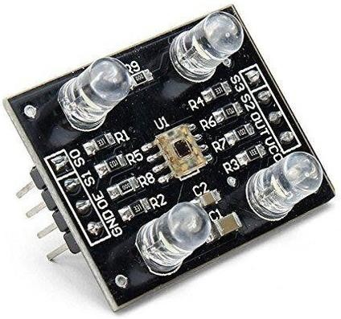

Fig 5.12: Color Sensor

If we take a closer look at the sensor, we can see how it detects various colors. The photodiodes have three different color filters. Sixteen of them have red filters, another 16 have green filters, another 16 have blue filters and the other 16 photodiodes are clear with no filters.

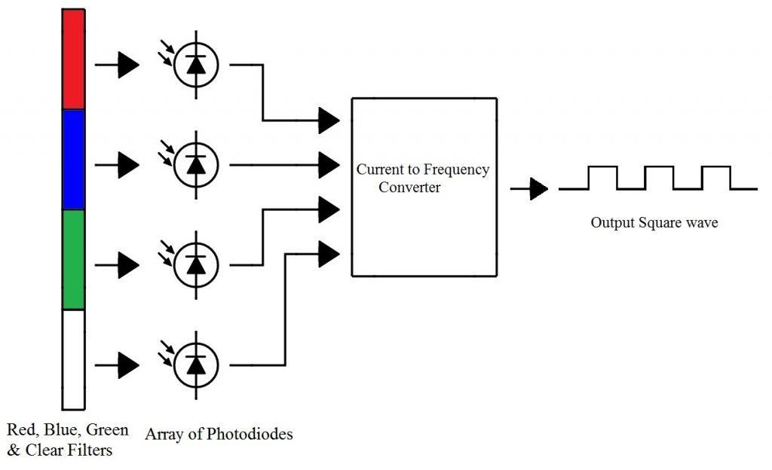

Fig 5.13: Working of Color Sensor

Each 16 photodiodes are connected in parallel, so using the two control pins S2 and S3 we can select which of them will be read. So, for example, if we want to detect red color, we can just use the 16 red filtered photodiodes by setting the two pins to low logic level according to the table 5.1.

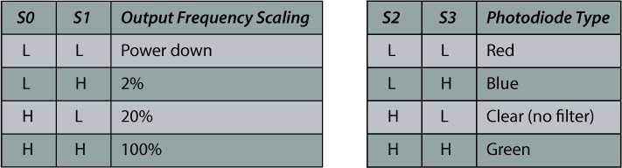

Table 5.1: Output frequency scaling and color display representation

The sensor has two more control pins, S0 and S1 which are used for scaling the output frequency. The frequency can be scaled to three different pre-set values of 100 %, 20 % or 2%. This frequency-scaling function allows the output of the sensor to be optimized for various frequency counters or microcontrollers. The connection of color sensor to Arduino board is represented by a schematic below.

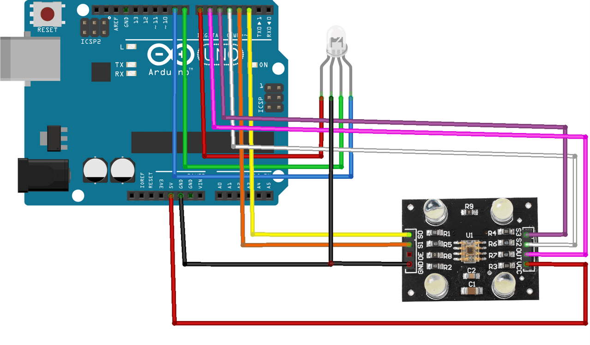

Fig 5.14: Interfacing of Color Sensor to Arduino

## DC Motor Driver

DC motor is used to provide locomotion to the robot. It is driven by the power supply circuit with 12V. DC motor used is compatible with the micro-controller. Common DC gear head motors need current above 250mA. There are many integrated circuits like ATmega16 Microcontroller, 555 timer IC. But, IC 74 series cannot supply this amount of current. When the motor is directly connected to the output of the above ICs then, they might damage. To overcome this problem, a motor control circuit is required, which can act as a bridge between the above motors and ICs (integrated circuits). There are various ways of making H-bridge motor control circuit such as using transistor, relays and using L293D/L298.

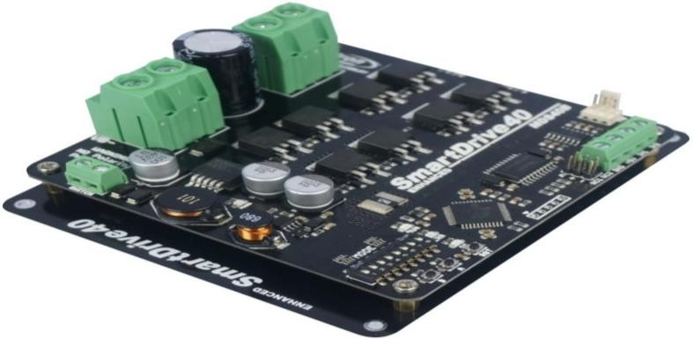

Fig 5.15: DC Motor Driver The pin details of L293D IC are described as follows:

**Pin-1(Enable 1-2)**: When the enable pin is high, then the left part of the IC will work otherwise it won’t work. This pin is also called as a master control pin.

**Pin-2 (Input-1)**: When the input pin is high, then the flow of current will be through output 1.

**Pin-3 (Output-1)**: This output-1 pin must be connected to one of the terminals of the motor.

**Pin4 &5**: These pins are ground pins.

**Pin-6 (Output-2)**: This pin must be connected to one of the terminals of the motor.

**Pin-7 (Input-2)**: When this pin is HIGH then the flow of current will be though output 2.

**Pin-8 (Vcc2)**: This is the voltage pin which is used to supply the voltage to the motor.

**Pin-9 (Enable3-4)**: When this pin is high, then the right part of the IC will work & when it is low the right part of the IC won’t work. This pin is also called as a master control pin for the right part of the IC.

**Pin-10 (Input-3)**: When this pin is high, then the flow of current will through output-3.

**Pin-11 (Output-3)**: This pin must be connected to one of the terminals of the motor.

**Pin-12 & 13**: These pins are ground pins.

**Pin-14 (Output-4)**: This pin must be connected to one of the terminals of the motor.

**Pin-15 (Input-4)**: When this pin is high, then the flow of current will be through output-4.

**Pin-16 (Vss)**: This pin is the power source to the integrated circuit.

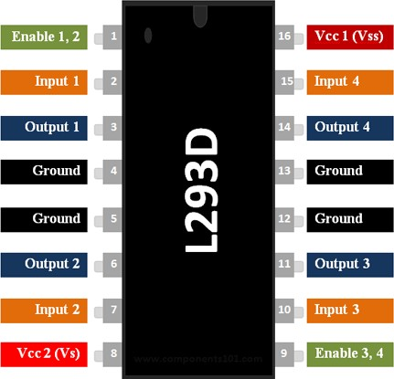

Fig 5.16: Pin Details of L293D IC

A H bridge is an electronic circuit that allows a voltage to be applied across a load in any direction. H-bridge circuits are frequently used in robotics and many other applications to allow DC motors to run forward & backward. These motor control circuits are mostly used in different converters like DC-DC, DC-AC, AC-AC converters and many other types of power electronic converters. In specific, a bipolar stepper motor is always driven by a motor controller having two H-bridges.

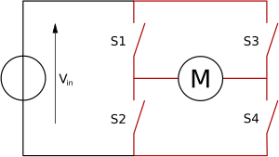

Fig 5.17: H - Bridge Connection

A H-bridge is fabricated with four switches like S1, S2, S3 and S4. When the S1 and S4 switches are closed, then a positive voltage will be applied across the motor. By opening the switches S1 and S4 and closing the switches S2 and S3, this voltage is inverted, allowing invert operation of the motor. Generally, the H-bridge motor driver circuit is used to reverse the direction of the motor and also to break the motor. When the motor comes to a sudden stop, as the terminals of the motor are shorted. Or let the motor run free to a stop, when the motor is detached from the circuit. The table below gives the different operations with the four switches corresponding to the above circuit.

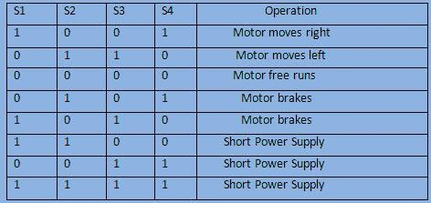

Table 5.2: Motor control operation

The IC L293D consists of 4-input pins where, pin2 and 7 on the left side of the IC and Pin 10 and 15 on the right side of the IC. Left input pins on the IC will control the rotation of a motor. Here, the motor is connected across side and right input for the motor on the right- hand side. This motor rotates based on the inputs we provided across the input pins as Logic 0 and Logic 1.

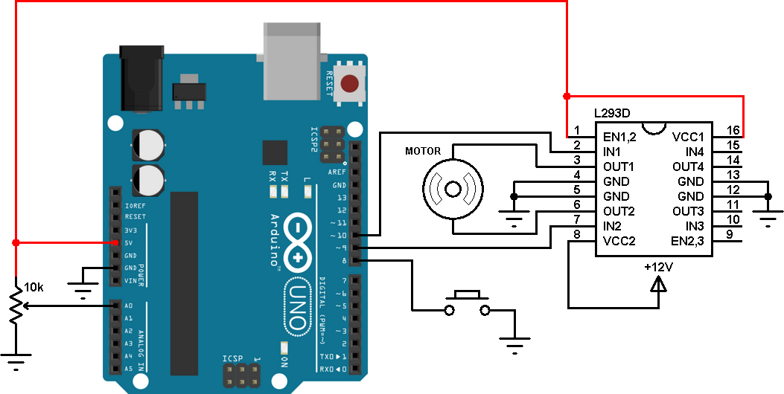

Fig 5.18: Driver Circuit [ L293D] Connection with Arduino

Let’s consider, when a motor is connected to the output pins 3 and 6 on the left side of the IC. For rotating of the motor in clockwise direction, then the input pins have to be provided with Logic 0 and Logic 1.

When Pin-2= logic 1 & pin-7=logic 0, then it rotates in clockwise direction. Pin-2= logic 0 & Pin7=logic 1, then it rotates in anti-clock direction. Pin-2= logic 0 & Pin7=logic 0, then it is idle (high impedance state). Pin-2= logic 1 & Pin7 = logic 1, then it is idle.

In a similar way the motor can also operate across input pin-15 and pin-10 for the motor on the right-hand side. The L293D motor driver IC deals with huge currents, due to this reason, this circuit uses a heat sink to decrease the heat. Therefore, there are 4-ground pins on the L293D IC. When we solder these pins on the PCB (printed circuit board), then we can get a huge metallic area between the ground pins where the heat can be produced.

## Electromagnetic Relays

A relay is an electrically operated switch. It consists of a set of input terminals for a single or multiple control signals, and a set of operating contact terminals. The switch may have any number of contacts in multiple contact form, such as make contacts, break contacts. It is similar to a switch, either open or closed. When the switch is open no current passes through the relay, the circuit is open, and the load that is connected to the relay receives no power.

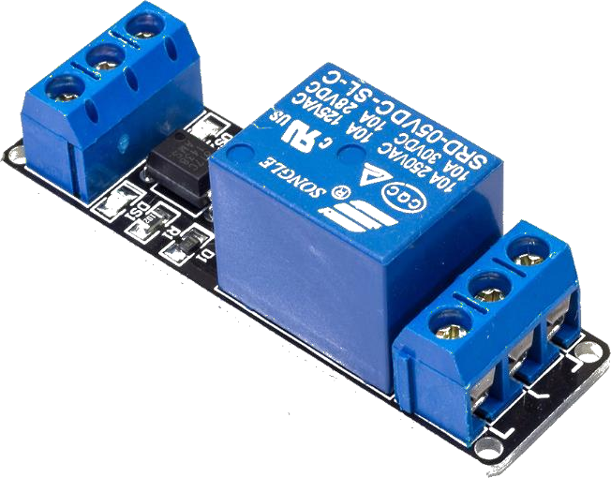

Fig 5.19: Electromagnetic Relay

When a relay is closed, the circuit is completed and current passes through the relay and delivers power to the load. To open and close a relay an electromagnet is used. When the coil controlling the electromagnet is given a voltage, the electromagnet causes the contacts in the relay to connect and transfer current through the relay.

The pin description of electromagnetic relays are as follows:

**COM**- Common pin

**NC**- Normally Closed, in which case NC is connected with COM when INT1 is set low and disconnected when INT1 is high;

**NO**- Normally Open, in which case NO is disconnected with COM1 when INT1 is set low and connected when INT1 is high.

Terminal 2 is similar to terminal 1, except that the control port is INT2.

**INT 1**- Relay 1 control port

**INT 2**- Relay 2 control port

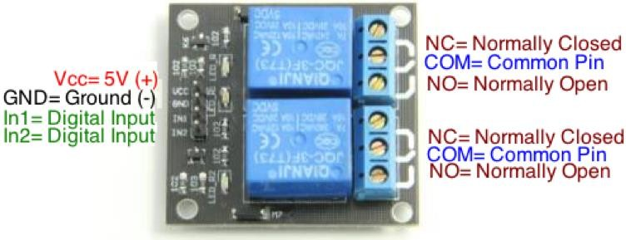

Fig 5.20: Pin Description of Electromagnetic Relays

## Node MCU

NodeMCU is an open source IoT platform. It includes firmware which runs on the ESP8266 Wi-Fi SoC, and hardware which is based on the ESP-12 module. The term "NodeMCU" by default refers to the firmware rather than the development kits.

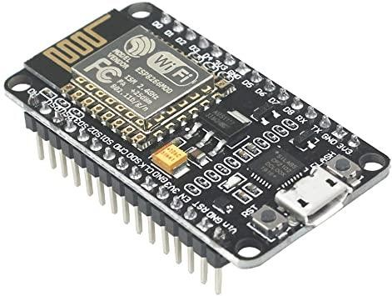

Fig 5.21: Node MCU

ESP8266 Wi-Fi module is a low cost standalone wireless transceiver that can be used for end-point IOT developments. Its Wi-Fi module enables internet connectivity to embedded applications. It uses TCP/UDP communication protocol to connect with server/client.

To communicate with the ESP8266 Wi-Fi module, Microcontroller needs to use set of AT commands. Microcontroller communicates with ESP8266-01 Wi-Fi module using UART having specified Baud rate.

## Wi-Fi Camera

An Internet Protocol Camera, commonly referred to as an IP camera, is a digital video camera much like a webcam, which transmits and receives data over a network or the internet. Unlike an ordinary webcam it is a standalone unit with its own IP address that requires nothing more than a network connection in order to transfer images. The IP camera connects to a network in exactly the same way as any other standard network device such as a laptop, tablet or printer.

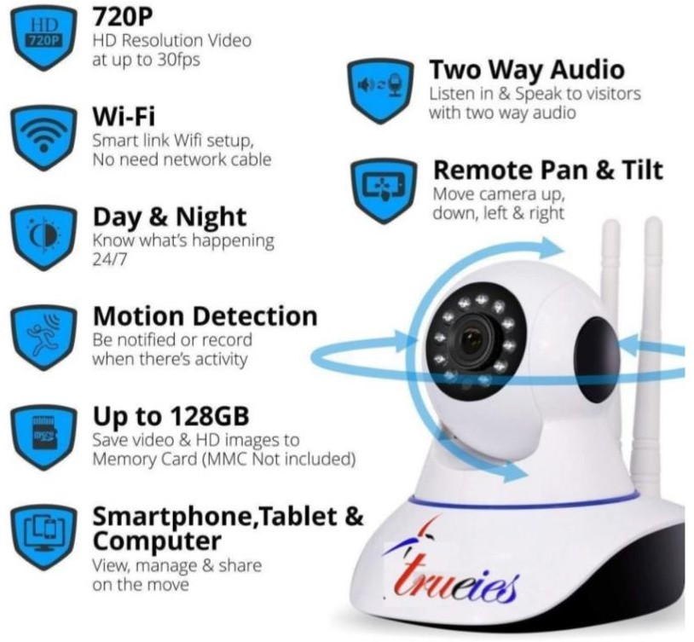

Fig 5.22: Wi-Fi Camera

IP cameras may be used with a wired network connected via ethernet cable to a broadband modem or router, or wirelessly via a Wi-Fi router. Setting up an IP Camera is relatively simple, requiring nothing more than a network connection and a little patience to site and configure the camera. The majority of IP Cameras on the market can be configured to

provide live viewing, continuous recording, operate at a scheduled time or be triggered by a specific event.

The images captured by an IP camera may be viewed from anywhere in the world via the internet, whether via pc, laptop or mobile phone. In many cases, as well as being able to view video footage and listen to audio streaming, the camera may also be controlled remotely.

IP Cameras acts as a versatile security solution, requiring nothing more than a network connection. There is no need for co axial cables, a computer station or even wired electricity. They can be used as a temporary or permanent solution, and relocated as and when required. IP cameras are available for both indoor and outdoor use, with both day and night functionality, and with the ability to pan or zoom either remotely or via operator command. Whether you require overt or covert security, there is an IP camera to suit.

# SOFTWARE DESCRIPTION

## CHAPTER VI

This chapter describes about the software used in this project to meet our needs. In the proposed system we have used Arduino IDE to program the Arduino mega board. The software description is as explained below:

## Arduino IDE

An integrated development environment (IDE) is a software application that provides comprehensive facilities to computer programmers for software development. An IDE normally consists of a source code editor, build automation tools and a debugger. Most modern IDEs have intelligent code completion. Some IDEs such as NetBeans and Eclipse contain a compiler, interpreter, or both; others such as SharpDevelop and Lazarus do not. The boundary between an integrated development environment and other parts of the boarder software development environment is not well defined. Sometimes a vision control system, or various tools to simplify the construction of a graphical user interface (GUI), are integrated. Many modern IDEs have a class browser, an object browser and a class hierarchy diagram, for use in object-oriented software development.



#### Overview

Fig 6.1: Logo of Arduino

Integrated development environments are designed to maximize programmer productivity by providing tight-knit components with similar user interface. IDEs present a single program in which all development is done. This program typically provides many features for authoring, modifying, compiling, deploying and debugging software. This contrasts with software development using unrelated tools, such as vi. GCC.

One aim of IDE is to reduce the configuration necessary to piece together multiple development utilities, instead of providing the same set of capabilities as a cohesive unit. Reducing that setup time can increase developer productivity, in cases where learning to use IDE is faster than manually integrating all the individual tools. Tighter integration of all development tasks has the potential to improve overall productivity beyond just helping with setup task. For example, code can be continuously parsed while it is being edited, providing instant feedback when syntax errors are introduced. That can speed learning a new programming language and its associated libraries.

Some IDEs are dedicated to a specific programming language, allowing a feature set that most closely matches the programming paradigms of the language. However, there are multiple language IDEs.

The Arduino IDE supports the languages C and C++ using special rules of code structuring. The Arduino IDE supplies a software library from the wiring project, which provides many common input and output procedures. User-written code only requires two basic functions, for starting the sketch and the main program loop(), that are compiled and linked with a program main() into an executable cyclic executive program with the GNU tool chain, also included with the IDE distribution. The Arduino IDE employs the program to convert the executable code to a text file in hexadecimal encoding that is loaded into the Arduino board by a loader program in the board's firmware.

#### Sketch

A program written with the Arduino IDE is called a sketch. Sketches are saved on the development computer as text files with the file extension .ino. Arduino software IDE pre1.0 saved sketches with extension .pde.

A minimal Arduino C/C++ program consists of only two functions:

1. setup() : This function is called once when a sketch starts after power up or reset. It is used to initialize variables, input and output pin modes, and other libraries needed in the sketch.
2. loop() : After setup() has been called, function loop() is executed repeatedly in the main program. It controls the board until the board is power off or reset.

While most IDEs are graphical, text-based IDEs such as turbo pascal were in popular use before the wide spread availability of windowing systems like Microsoft Windows and X Windows System(X11). They commonly use function keys or hotkeys to execute frequently used commands or macros.

#### Getting started with Arduino

1. Getting an Arduino board and USB cable
2. Download the Arduino IDE software
3. Connect the board
4. Install the drivers
5. Launch the Arduino application

Arduino also simplifies the process of working with microcontrollers and it offers some advantage such as:

****Inexpensive** - Arduino boards are relatively inexpensive compared to other microcontroller platforms. The least expensive version of the Arduino module can be assembled by hand, and even the pre-assembled Arduino modules cost less than $50. **Cross-platform** - The Arduino Software (IDE) runs on Windows, Macintosh OSX, and Linux operating systems. Most microcontroller systems are limited to Windows.

****Simple, clear programming environment** - The Arduino Software (IDE) is easy to use for beginners, yet flexible enough for advanced users to take advantage of as well. **Open source and extensible software** - The Arduino software is published as open source tools, available for extension by experienced programmers. The language can be expanded through C++ libraries, and people wanting to understand the technical details can make the leap from Arduino to the AVR C programming language on which it is based.

***Open source and extensible hardware** - The plans of the Arduino boards are published under a Creative Commons license, so experienced circuit designers can make their own version of the module, extending it and improving it.

## Blynk

Blynk is a toolset for all makers, designers, teachers, and geeks who use their smart phones to control electronics like Arduino, RaspberryPi and similar ones. With Blynk, we can snap with amazing interfaces with different gadgets. It works perfectly and saves tons of time.

Blynk will work with all popular boards and shields. Blynk Cloud is much more convenient which is free and an open-source platform helping in creating projects. Blynk is very powerful and simple where drag and drop of controllers (buttons, timers), displays (Value display, LCD), notifications and other functional widgets makes our work less cumbersome. Blynk is not an app that works only with a particular shield. Instead, it is been designed to support the boards and shields we are already using. And it works on iOS and Android.

Blynk also works over USB. This means you can tinker with the app by connecting it to your laptop or desktop while waiting for some internet shield to arrive. Blynk works over the Internet. So, the one and only requirement is that your hardware can talk to the Internet. No matter what type of connection we choose - Ethernet, Wi-Fi or maybe this new ESP8266 Blynk libraries and sketches will be connected to Blynk Server and pair up with our smartphone.

Blynk libraries work with:

* USB
* Ethernet shield
* Wi-Fi shield
* Arduino with Ethernet
* Raspberry Pi (Blynk will communicate with Pi's GPIOs)

It's not that easy to take Arduino out of your home network, so we've built a Blynk server. It handles all the authentication and communication, and also keeps an eye on the board while the smart phone is offline. Blynk server runs on Java and is open-source. Messaging between mobile apps, Blynk Server and Arduino is based on a simple, lightweight and fast binary protocol over TCP/IP sockets.

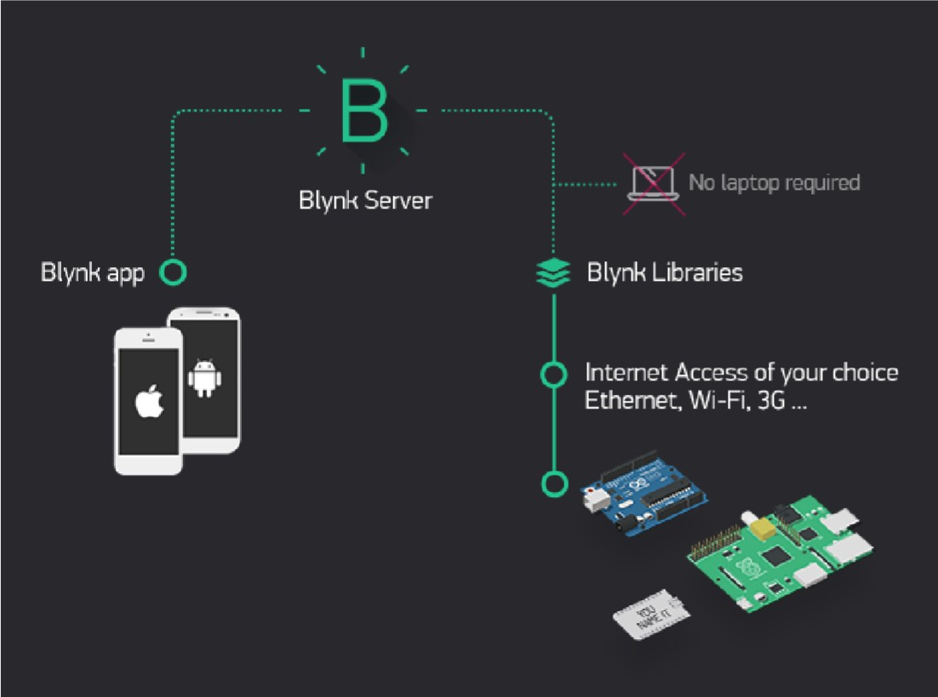

Fig 6.2: Pairing up of Blynk Server with Smart Phone There are three major components in the platform:

1. **Blynk App**: It allows you to create amazing interfaces for your projects using various widgets which are provided.
2. **Blynk Server**: It is responsible for all the communications between the smartphone and hardware. You can use the Blynk Cloud or run your private Blynk server locally. It’s opensource, could easily handle thousands of devices and can even be launched on a RaspberryPi.
3. **Blynk Libraries**: It enables communication, for all the popular hardware platforms, with the server and process all the incoming and outcoming commands.

##### Creating a project using Blynk App

A smart phone, IoT hardware and an internet connection are the basic modules for Blynk application. Blynk can run on over 400 hardware modules. The most popular are ESP8266, ESP32, NodeMCU, Arduino (any model), Raspberry Pi (any model) etc., To connect our hardware to the Internet, we can choose almost any module either built-in, or external shields. Initially we need to download Blynk app for iOS or Android devices which is the easiest way to build our own mobile application that work with the hardware of our choice. Next, we need to install the Blynk libraries which is an extension that runs on top of our hardware application. It handles all the connection routines and data exchange between our hardware, Blynk Cloud, and our application project. After this we need to create an account and we need to login by proving valid credentials. In order to get our hardware online and connect it to Blynk Cloud, we would need a device Authentication Token. After our hardware is connected to Blynk we are ready and we get a message saying " Welcome to Blynk ".

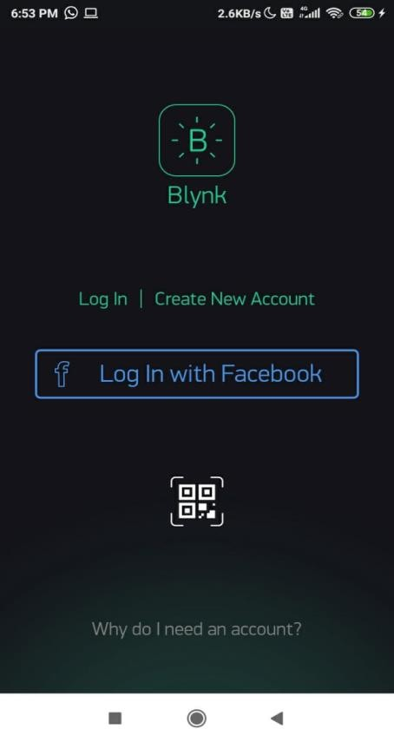

Fig 6.3: Creating a new project in Blynk App

##### Create a Blynk Project

In order to create a new project application in Blynk, we need to first click on “New Project” in the app. Then enter the project name “Amigo” and make sure the “Hardware Model” is set to ESP8266 as represented in the figure below.

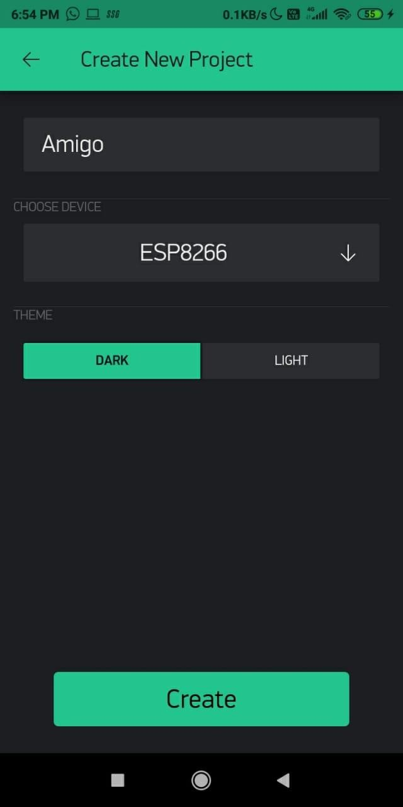

Fig 6.4: Selecting ESP8266 Hardware Model after creating Amigo Project

Once after the confirmation of selection of hardware to ESP8266 and project title, the Blynk app asks for validation. Here we need to enter out valid credentials and login with the Blynk server. Once after the verification of details entered, we obtain an Authentication token for the registered mail Id. After these validations we are now authorized to use the Blynk application. The authentication token is very important as it registers the ESP8266 module to your application.

After this, various functional widgets are accessible. We can use the widgets based on the energy level present. Here in Blynk application each and every widget that may be a LCD display, button, GPS stream etc... consumes some amount of energy. Based on the energy left out we are liable to choose widgets of our interest. The different functional widgets available are represented in the figure given below.

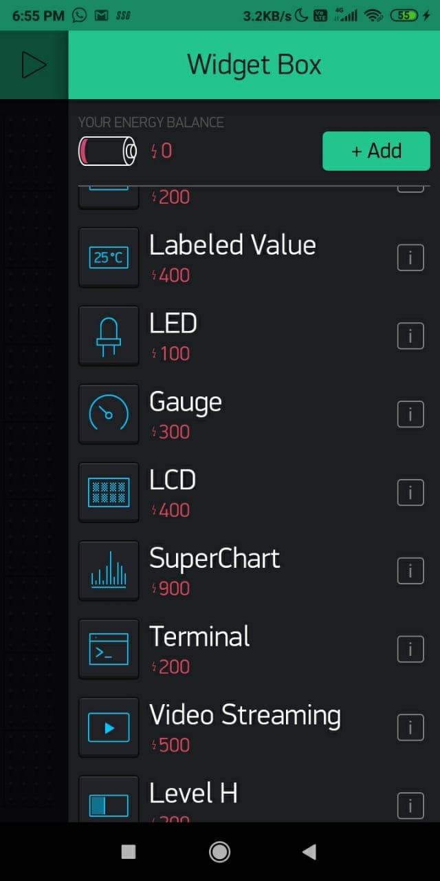

Fig 6.5: Few functional widgets available

##### Upload the Blynk Firmware

Now that our Blynk project is set up, open Arduino and add the Blynk libraries which are required for communicating with the Arduino. With addition to including of required libraries we also have to make sure to paste our authorization token into the auth[] variable. Also make sure to load your Wi-Fi network settings into the Blynk.begin(auth, "ssid", "pass") function. Then the upload process is said to be completed.

##### Run the Project

After the app has uploaded, open the serial monitor, setting the baud rate to 9600. Wait for the “Ready” message. Then click the “Run” button in the top right corner of the Blynk app. Press the button and watch the LED. Once the Blynk application is connected via your smart phone hotspot, it shows that we are online and the controlling can be done successfully.

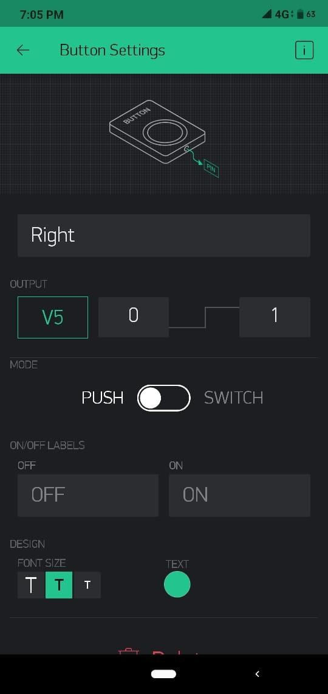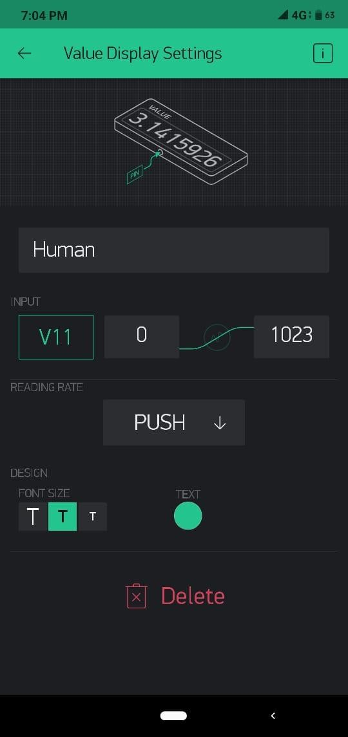

Fig 6.6: Snapshots of button and value display settings

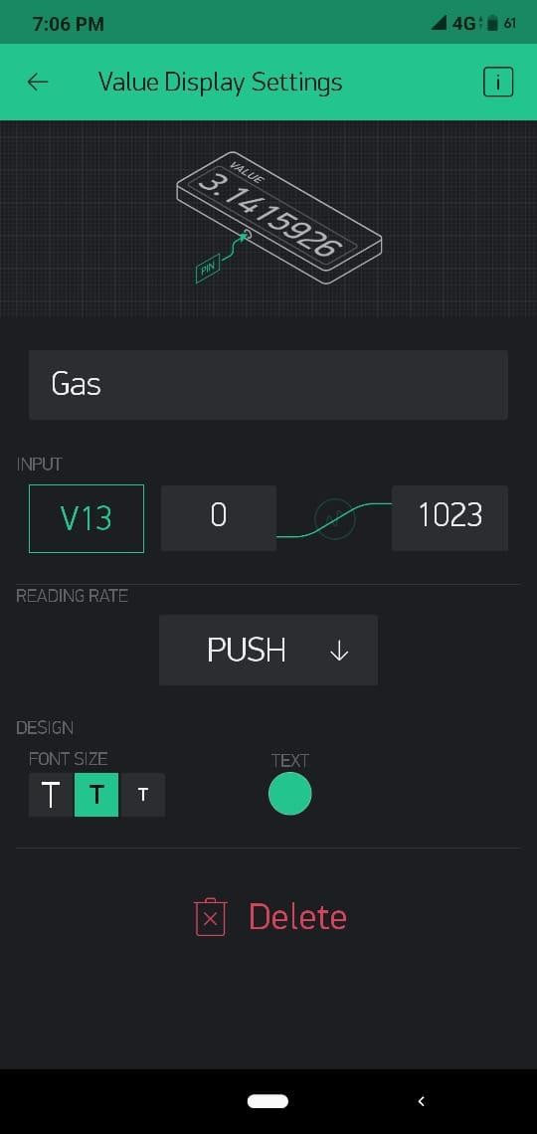 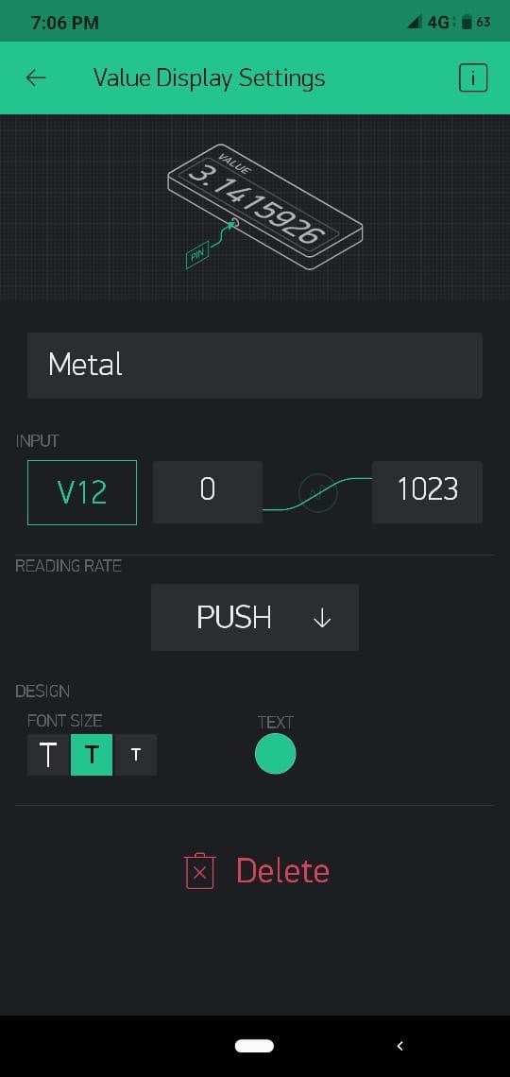

Fig 6.7: Snapshots of gas and metal sensors

We can add more widgets to the project based on our requirement and feasibility. They should immediately work on the ESP8266 without uploading any new firmware. In this way Blynk application which is a drag-n-drop application constructor packed with IoT features such as visualizing and plotting data from any sensor, controlling relays, motors, and getting push notifications and so on, acts as a promising tool to work with in the upcoming era.

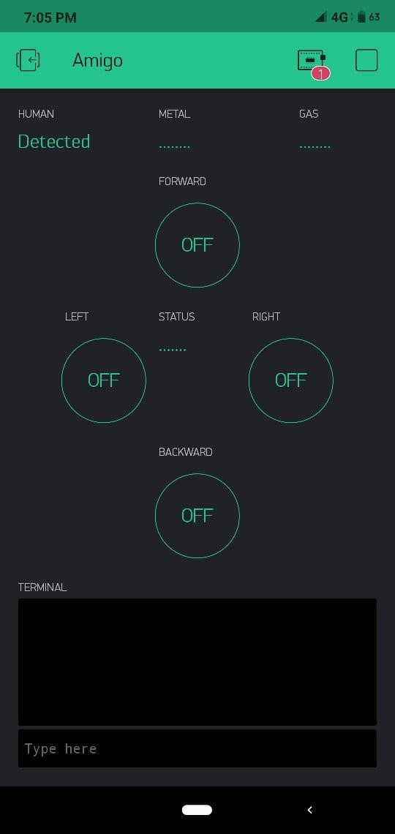

Fig 6.8: Controlling the motion of robot through mobile hotspot

## Live video streaming

For video live streaming, a Wi-Fi camera based on IP address is used. The live video streaming can be viewed in the mobile by using an android application named V380S.

The V380S is a new generation intelligent household cloud camera which can easily realize the remote video monitoring and management. By this software, the process of real- time video can be viewed anytime and anywhere. It supports the remote PLZ control. The camera direction can be controlled in this mobile application. The added advantage in this application is that the audio commands can be sent for the surveillance purpose. Intelligent cloud streaming transmission technology with 720p million high-definition public network

real-time transport is used. The V380S application increases cloud storage services where the video can be uploaded to the server with enhanced data security.

The V380S application expects us to create a new account and we need to provide the login credentials to do so and it is shown in the following figure (Fig 6.9).

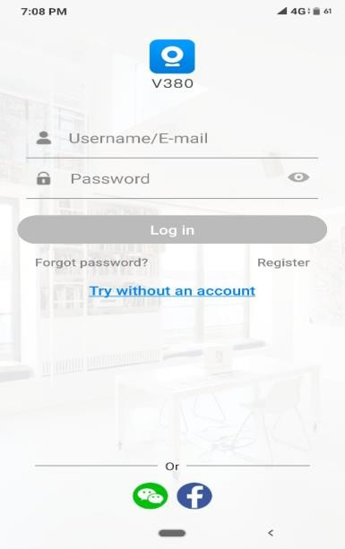

Fig 6.9: Creating an account in V380 App

Fig 6.10 shows the application’s interface along with few pictures captured using the camera during the movement of Amigo.

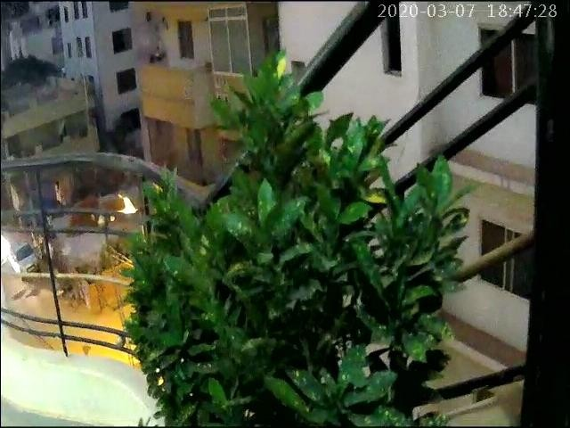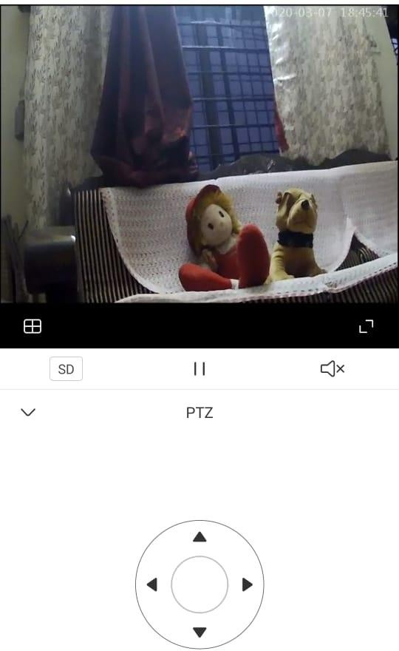

Fig 6.10: Snapshot of Video streaming Display settings

# RESULTS

## CHAPTER VII

A low cost Army Robot with Camouflaging feature named “Captain AMIGO” is designed and manufactured as shown in figures (Fig 7.1-7.4). The movement of the robot is controlled using Blynk app and also the output of the all the sensors is displayed on the mobile screen and the live video streaming is displayed in V380S app as shown in Fig 7.5.

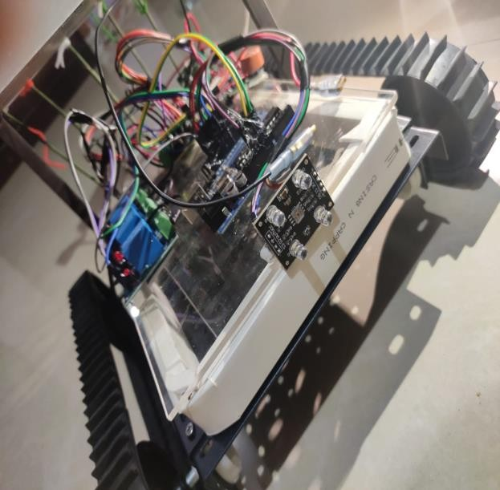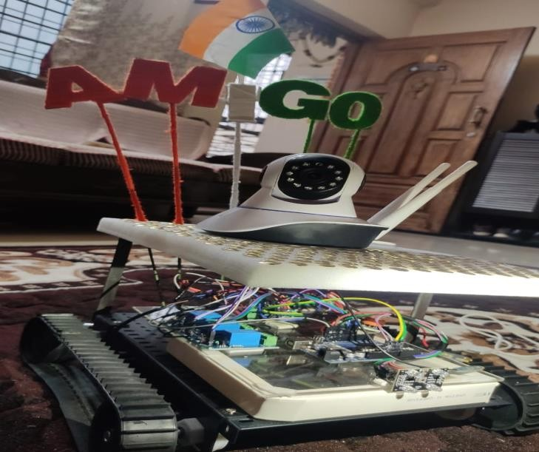

Fig 7.1: Captain Amigo

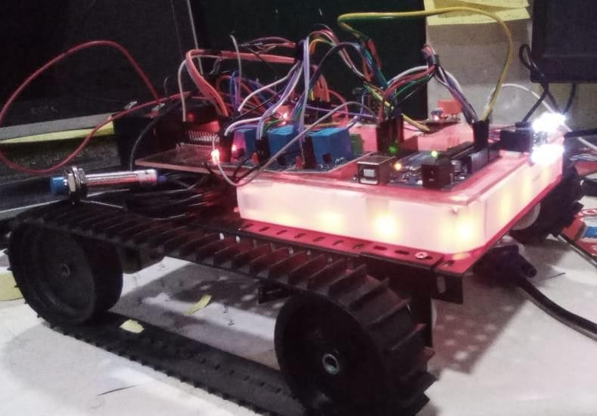

Fig 7.2: Red color Detection

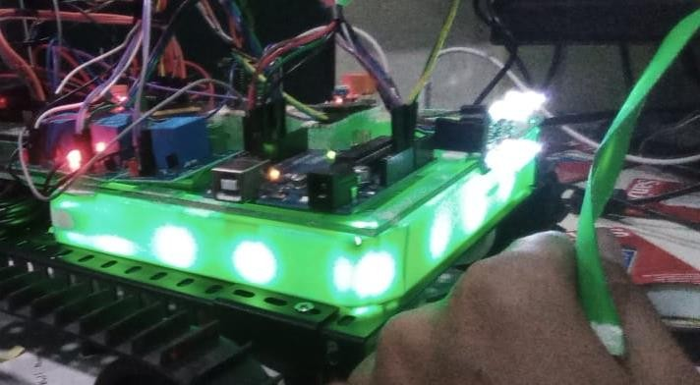

Fig 7.3: Green color Detection

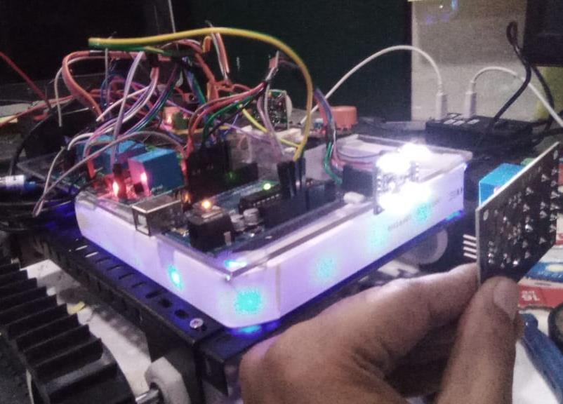

Fig 7.4: Blue color Detection

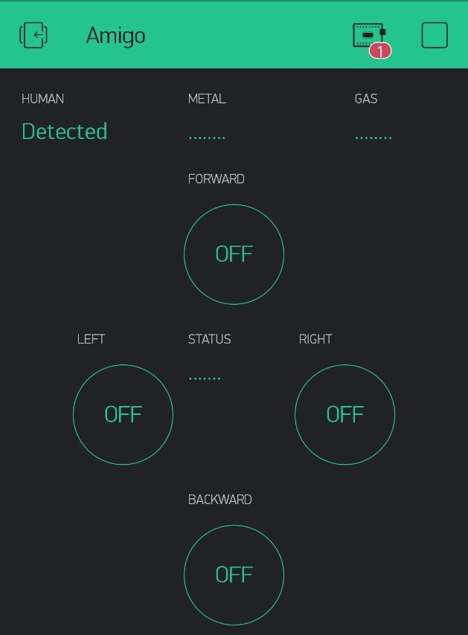 

Fig 7.5: Blynk app and V380S app snapshots

# APPLICATIONS AND FUTURE WORKS

## Applications

* This project can be used for performing multi-tasks .
* Further this robot can be extended to perform stealth and ability to maneuver in inaccessible areas.
* Various sensors like PIR, IR, gas sensor, color sensor, metal detector etc. make this vehicle more effective.
* In military application, this robot can be used to detect the presence of human being.
* It can be used in rescue operation where human reach is not possible.
* This camouflage robot can be utilised in the tracking systems.
* Army Robot is an autonomous robot comprising of wi-fi camera which can be used as a spy (surveillance purpose).
* Robot can further be equipped with speaker or recorder to interact with survivor and assure them of nearby help.

## Future scope

The proposed system provides a helping hand to our security forces in detection of intruders. The robot can also be used in high altitude areas where human cannot survive. Moreover, the camouflaging feature makes it difficult to detect the robot by naked human eye. There is scope to improve the system by configuring it with multicolor camouflaging. It can also be incorporated with the Amazon Kindle which is basically predominant for readers allowing them not strain their eyes in any lighting conditions. Displaying an opposite side image on it makes it camouflaged and with the help of its zero reflecting screen it can be more predominant.

# CONCLUSION

Military warfare has seen a decreased fatality rate in their personnel over the recent years in this modern world. The crust of the reason being the advancement in technologies that enable designing and development of unmanned robots to function in unfavourable areas for humans. The evolution of various forms of robots from rovers to humanoids has dealt with the crisis of human loss especially in covert missions and spy operations. The proposed system specifications that mainly relies on a concealment technique to avoid detection resonates with these advancements in military unit.

The implementation of various sensors has proven to have a high success rate. Starting with the color sensor which is the primary device used for cloaking, has been implemented along with RGB lights to give the desired camouflaging technique. This methodology can be a stepping stone for further advancements in the spy surveillance of the enemy territory. This efficiently helps the armies to send in rovers to recover information and infiltrate enemy campsite.

The use of a camera with dual properties of daytime and night vision recording further boosts the efficiency of the live streaming and recoding which is the main mode of surveillance. The use of applications such as BLYNK has improved the scope of manoeuvring the robot as the DC motors have been easily linked with the application. Use of IOT and Wi-Fi module has proven advantageous and helped in the easy 2-way communication between user and the unmanned robot.

The importance of having various other sensors and features to claim the multi functionality of the robot is tested and proved. The use of metal sensors to detect metals can be used as a bomb detector. The gas sensors used can be modified further to detect the harmful gases that are naked to the human eye. The IR and PIR sensors help in the detection of obstacles and humans which can be used to alert the operator and also used in rescue missions.

The overall composure of the proposed system not only satisfies the above criteria but also provides a cost effective and efficient multifunctional prototype. Further implementation of the system in real time with more advanced technologies can prove more worthy of its

##### Captain Amigo:An Army Robot Using IoT

blueprint that’s depicted by this system. There is scope to improve the system by configuring it with multi-color camouflaging. Overall, Amigo acts as a saviour and leads from the front like a captain and ensures that the more valuable lives are saved and their labour and hard-work is used at the right place and not in places that risk their lives.

# REFERENCES

* 1. Dr. S. Bhargavi, S. Manjunath, “Design of an Intelligent Combat Robot for war fields”, Department of Electronics and Communication Engineering, S.J.C.I.T, Chikballapur, Karnataka, India.
  2. Akash Kumar and Ananth Shanbog M “Development of camouflage technique based multifunctional army robot” International Journal of Advance Research in Science and Engineering Volume 7.
  3. P. Hymavathi, T. Jyothy “Surveillance Alive Human Detection Robot using Zigbee Technology” SSRG International Journal of Electronics and Communication Engineering (SSRG-IJECE) – volume issue 4 June 2014.
  4. Premkumar. M “UNMANNED MULTI-FUNCTIONAL ROBOT USING ZIGBEE ADOPTER NETWORK FOR DEFENSE APPLICATION” International Journal of Advanced Research in Computer Engineering & Technology (IJARCET)Volume 2, Issue 1, January 2013.
  5. Akash Ravindran, Akshay Premkumar, "CAMOUFLAGE TECHNOLOGY", Department of Electronics & Communication Engineering, IJETCSE, 2014.
  6. K. S. Kumar, M. R. Elara, E. A. Martinez and R. C. Ambrosio, "Designing and experimenting bio-inspired chromatic behaviours in surveillance robot," 2015 10th International Conference on Information, Communications and Signal Processing (ICICS), Singapore, 2015.
  7. A.M. Siddek, "Depth-level based camouflaging using RGB-D sensor," 2017 IEEE International Conference on Systems, Man, and Cybernetics (SMC), Banff, AB, pp. 2349- 2354, 2017.
  8. A. Rodic, D. Katie and G. Mester, "Ambient intelligent robot-sensor networks for environmental surveillance and remote sensing," 7th International Symposium on Intelligent Systems and Informatics, Subotica, 2009, pp. 39-44, 2009.
  9. B. Ammar, N. Rokbani and A. M. Alimi, "Learning system for standing human detection," 2011 IEEE International Conference on Computer Science and Automation Engineering, Shanghai, pp. 300-304, 2011.

##### Captain Amigo:An Army Robot Using IoT

* 1. Brett Browning and Manuela Veloso “Real-Time, Adaptive Colour-based Robot Vision” August 2005, Conf.loc. Edmonton, Alta., Canada, 2005.